Garage Management system

**College Name: Nandha Arts and Science College College Code: bru4j**

**TEAM SIZE:4**

**TEAM MEMBERS:**

**Team Leader Name:** Mithunkumar

**Email:** mithucj07@gmail.com

**Team Member:** MIRLIN KANTH R

**Email:** mirlinkanth2006@gmail.com

**Team Member:** l.Manikandan

**Email:** vasanseeini798@gmail.com

**Team Member:** Kathiravan A

**Email:** kathiravankathiravan537@gmail.com

# INTRODUCTION

## Project Overview

The Garage Management System (GMS) is a software solution developed to simplify and automate the daily operations of automobile service centers. It provides an integrated platform to manage customer details, vehicle information, job assignments, spare parts inventory, billing, and reporting.The system eliminates the challenges of traditional manual methods, such as misplaced records, delayed service, and inventory mismanagement. By offering real-time data access and automation, the GMS improves workflow efficiency, enhances accuracy, and reduces human effort. Ultimately, it helps garages deliver faster and more reliable services, leading to improved customer satisfaction and better business performance.

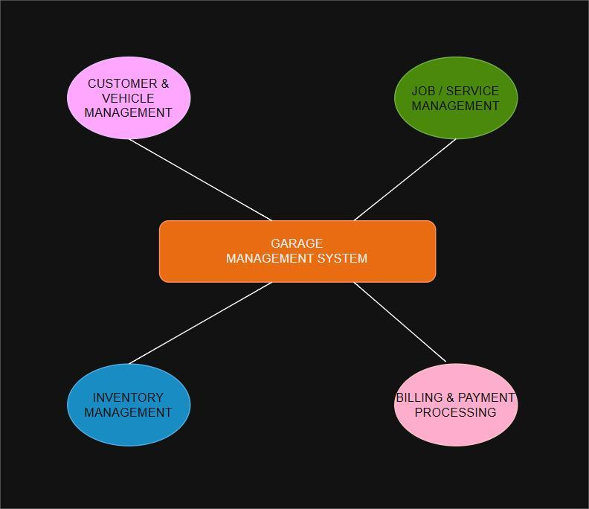

## Purpose

The main purpose of the Garage Management System is to automate and streamline the daily operations of automobile service centers. It reduces dependency on manual records by providing a digital platform to manage customers, vehicles, repair jobs, spare parts, and billing activities. Accurate and quick record-keeping of customer and vehicle details.

Efficient job assignment and progress tracking for mechanics. Real-time monitoring of spare parts inventory. Instant invoice generation and payment tracking. Improved communication between staff and customers. By integrating these features, the GMS enhances operational efficiency, minimizes errors, and improves overall customer satisfaction.

# DEVELOPMENT PHASE

### Creating Developer Account:

By using this URL **- https://**[**www.salesforce.com/form/developer-signup/?d=pb**](http://www.salesforce.com/form/developer-signup/?d=pb)

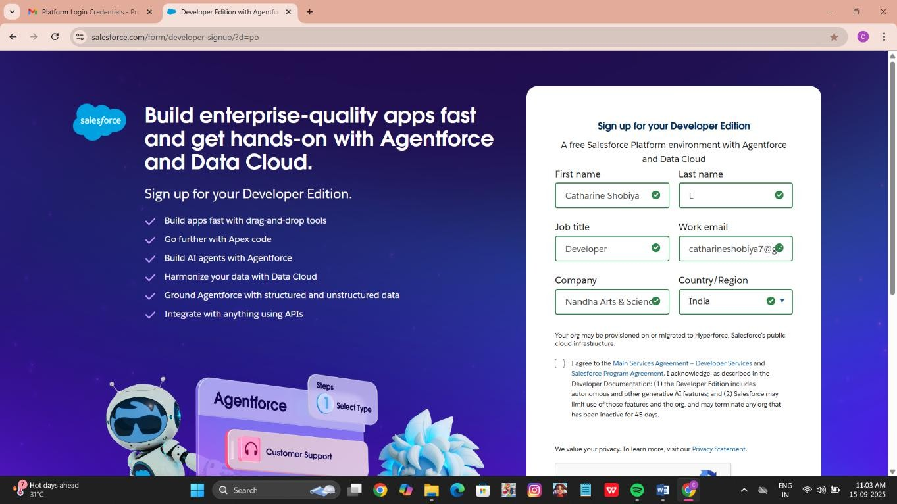

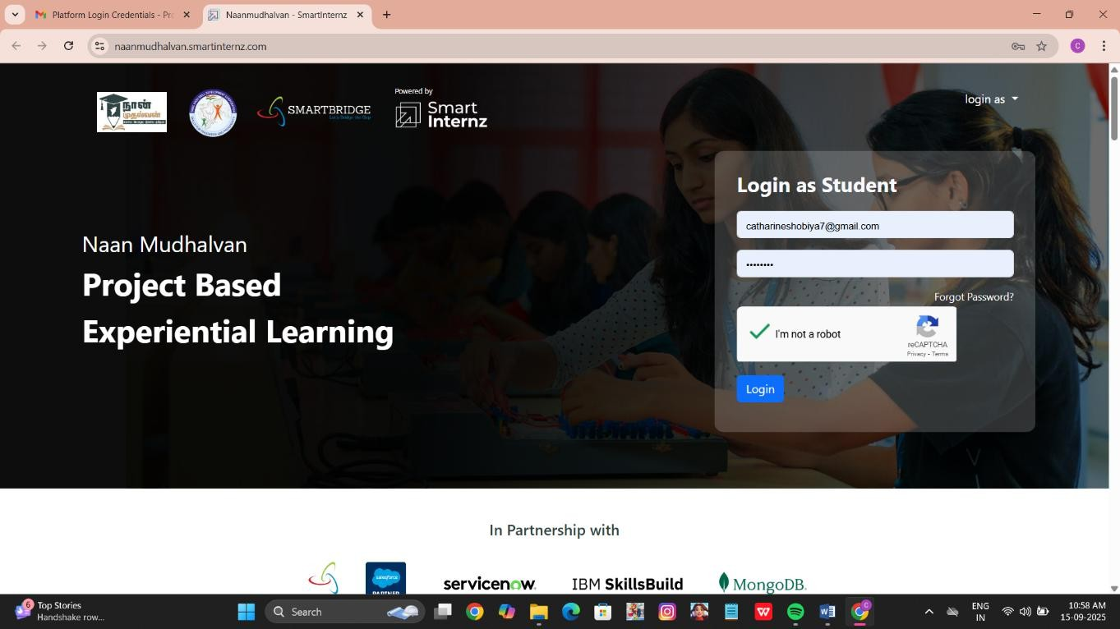

* + - Created objects: Customer Details, Appointment, Service records, Billing details and feedback

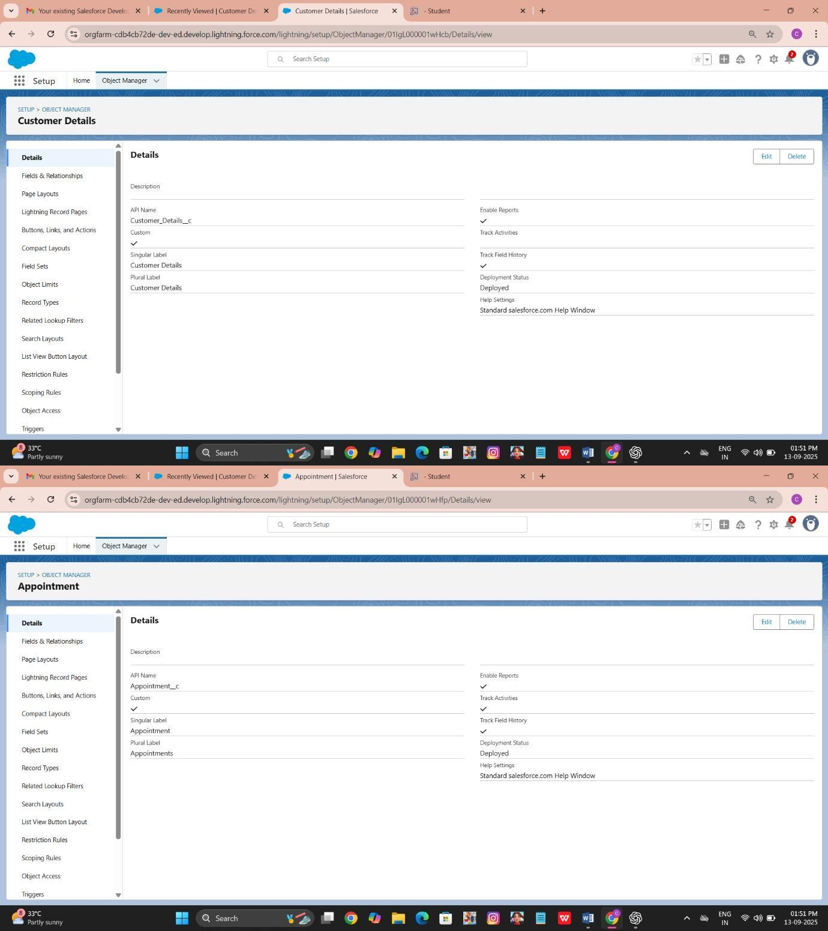

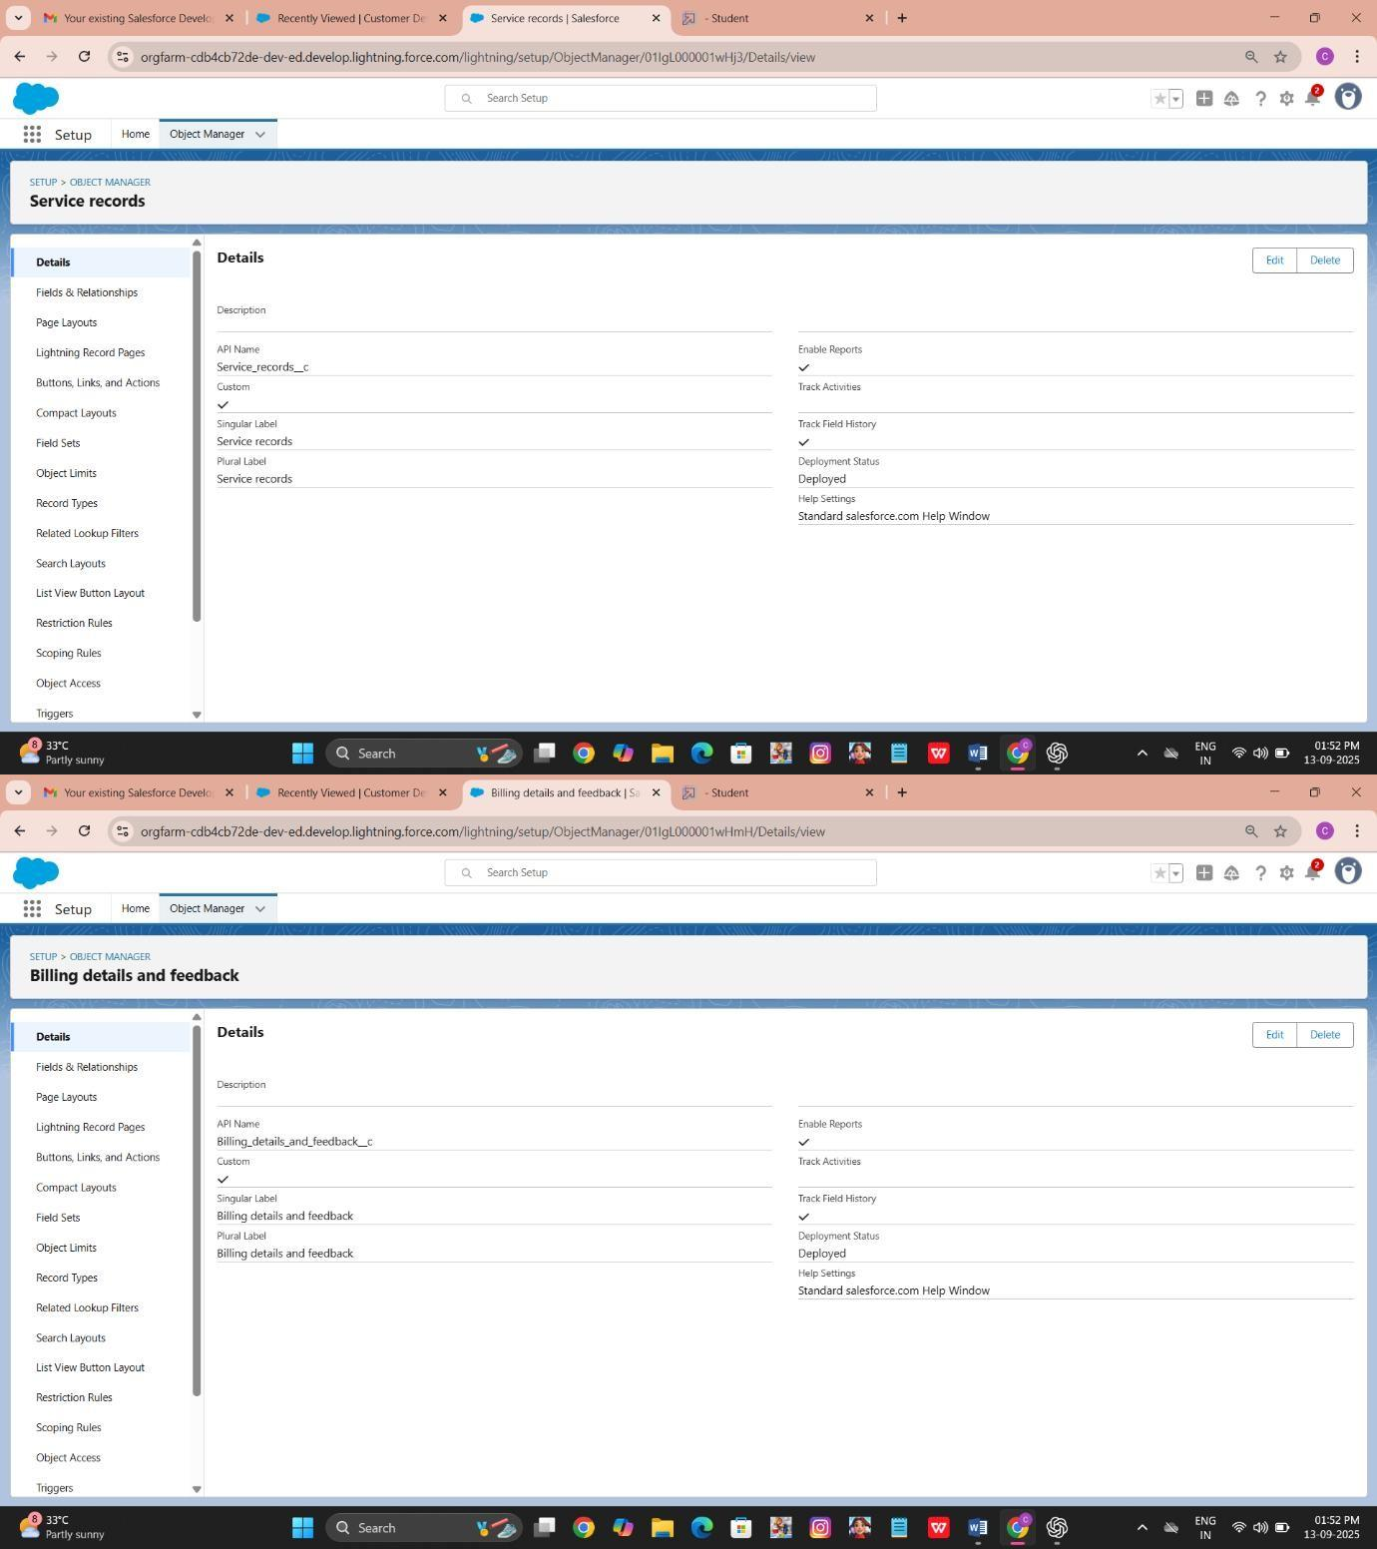

* + - Configured fields and relationships

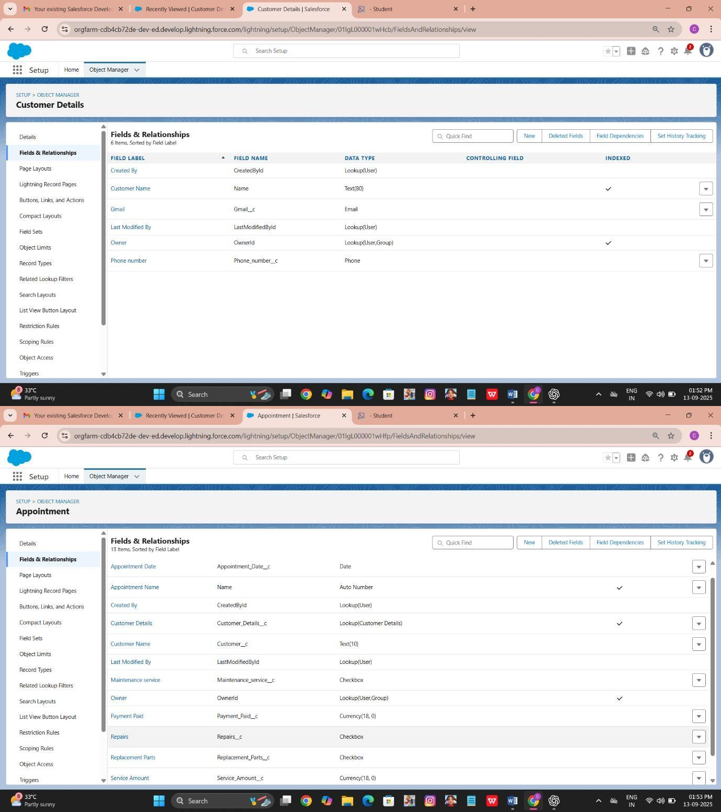

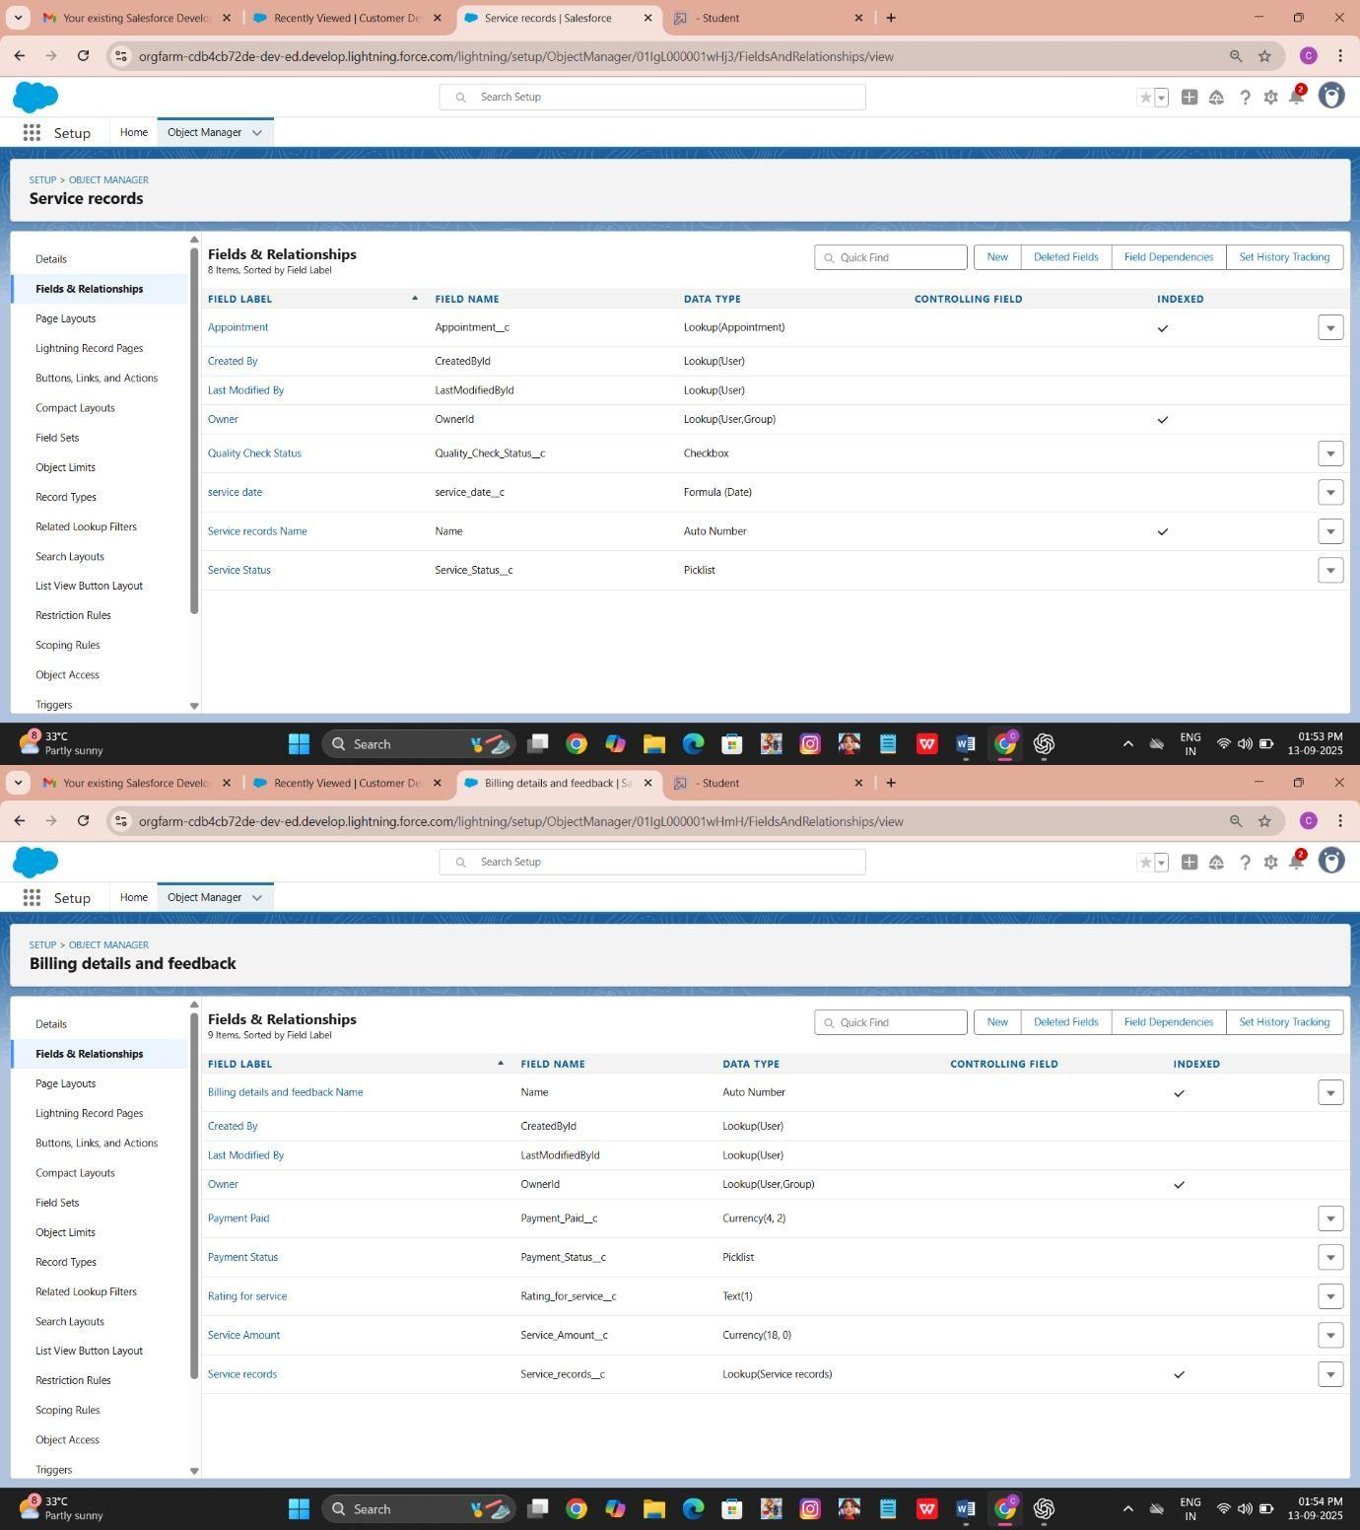

* + - * Creating tabs: Customer Details, Appointment, Service records, Billing details and feedback

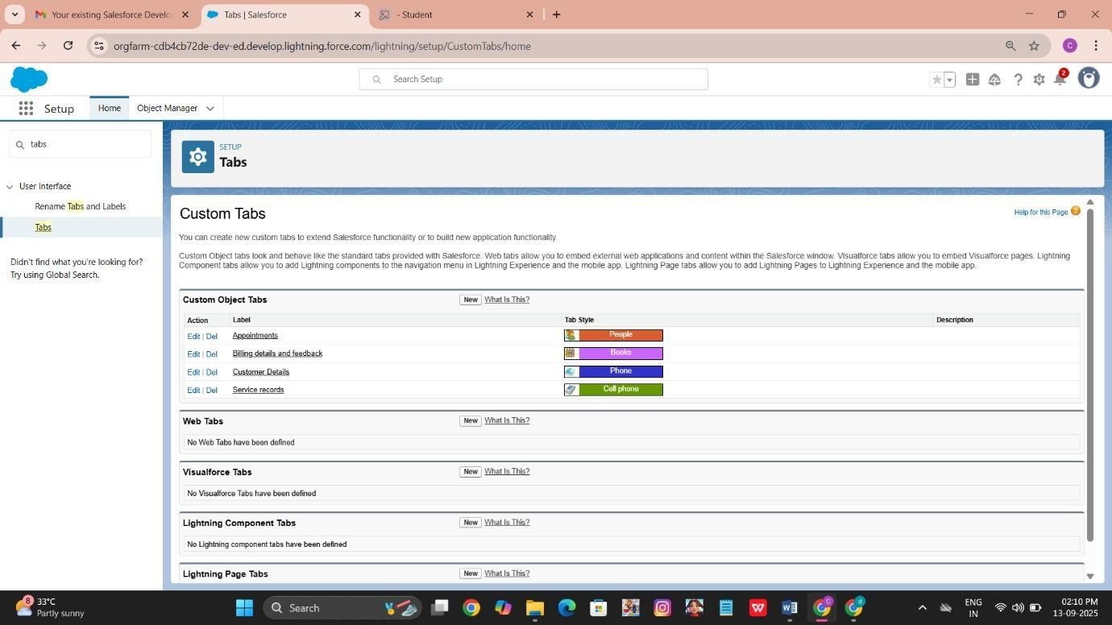

* + - * 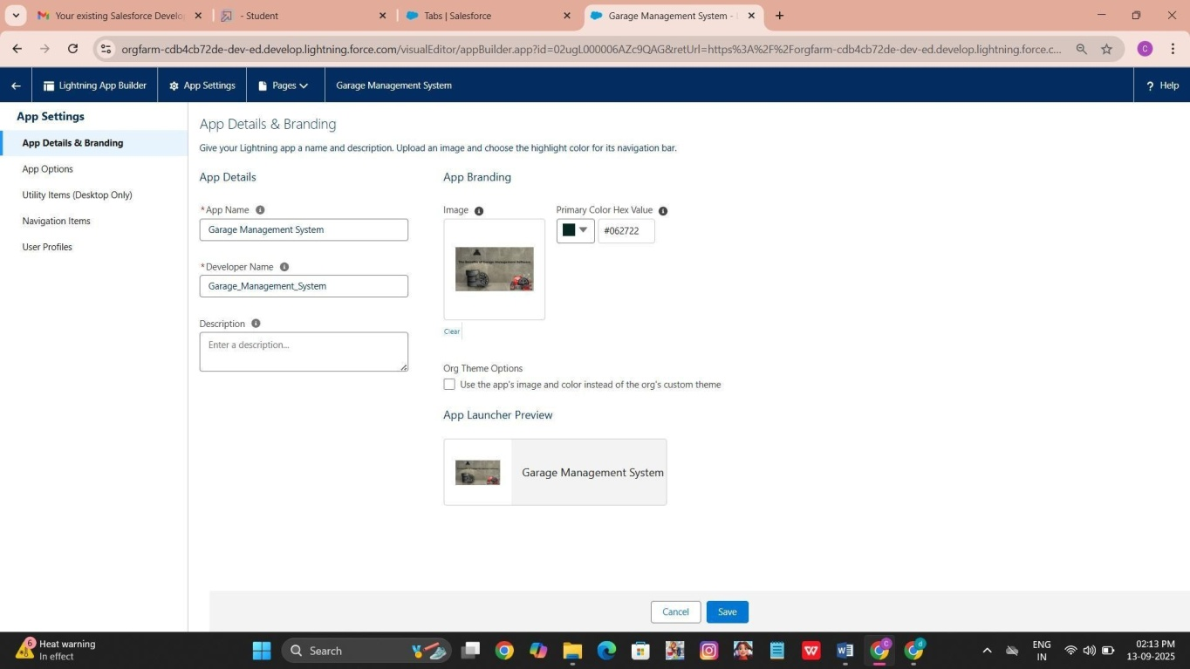Developed Lightning App with relevant tabs z

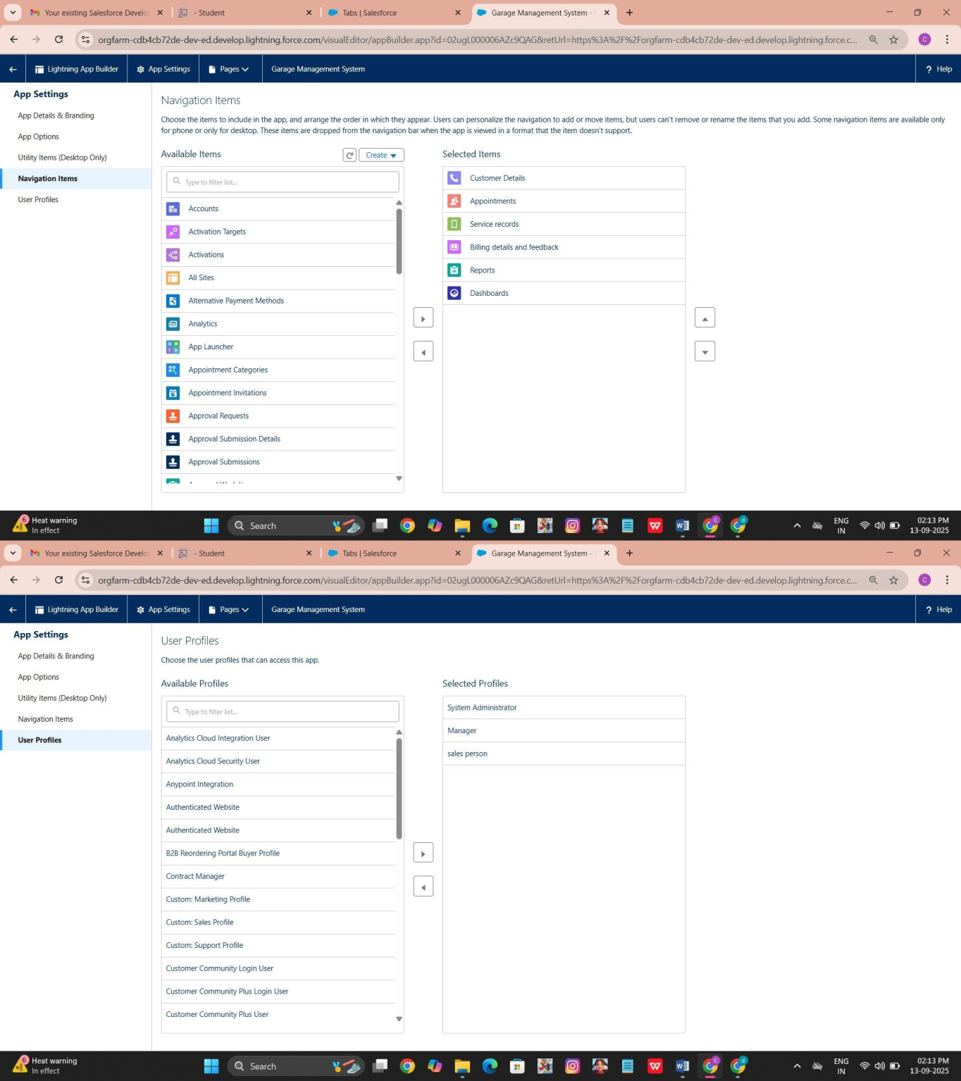

* + - * Creation of fields for the Customer Details object

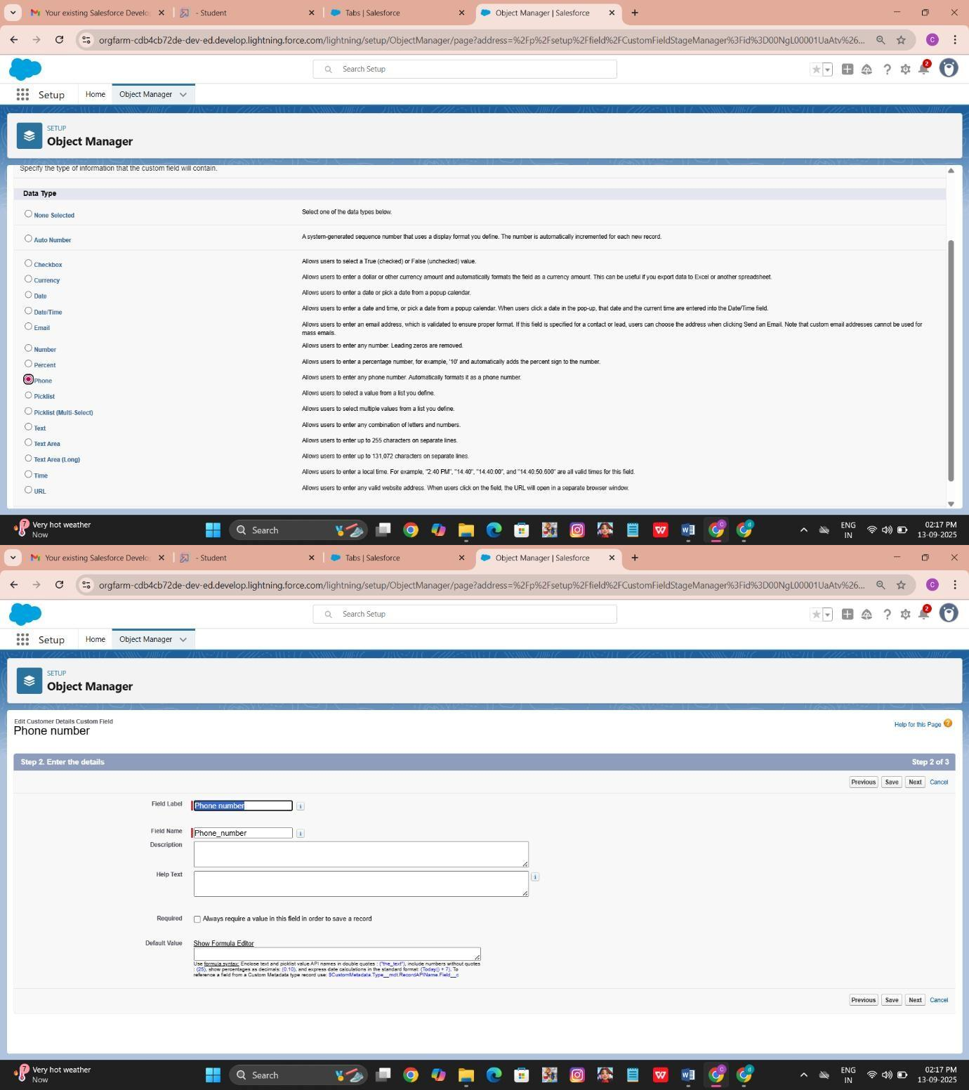

* + - * + For lookup field,

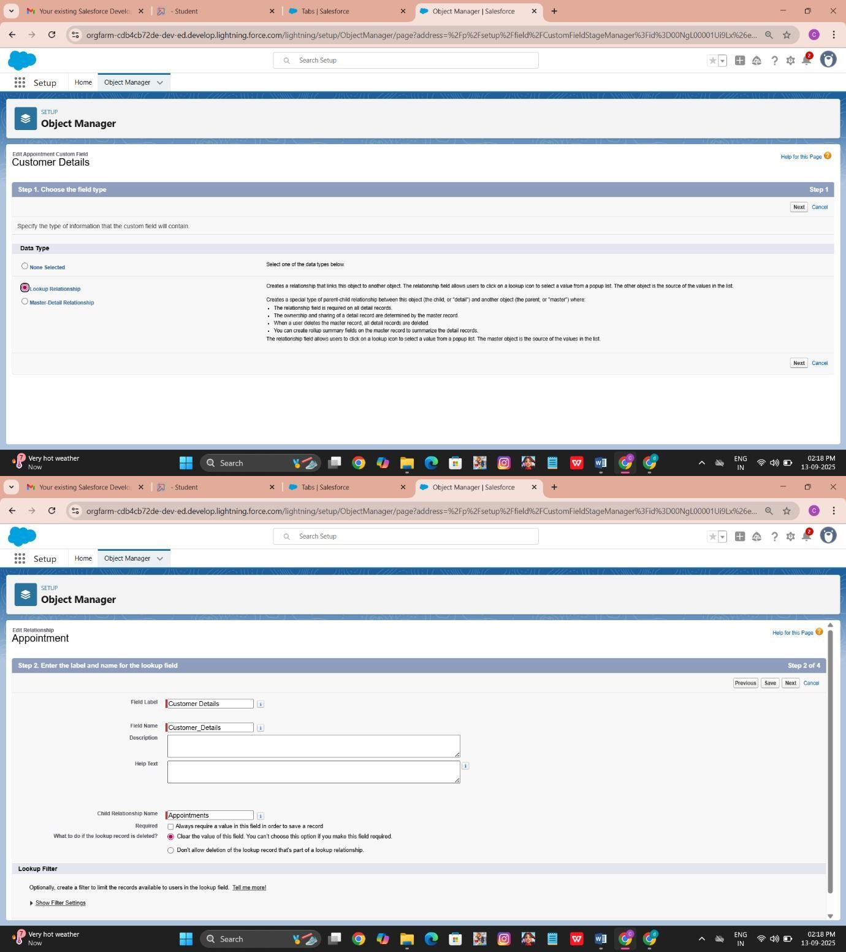

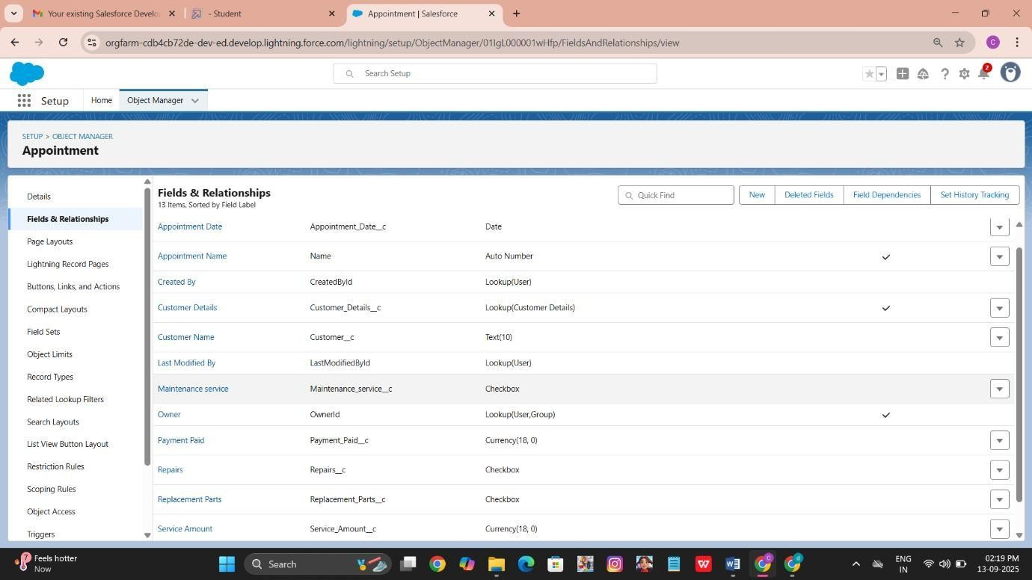

* + - * + 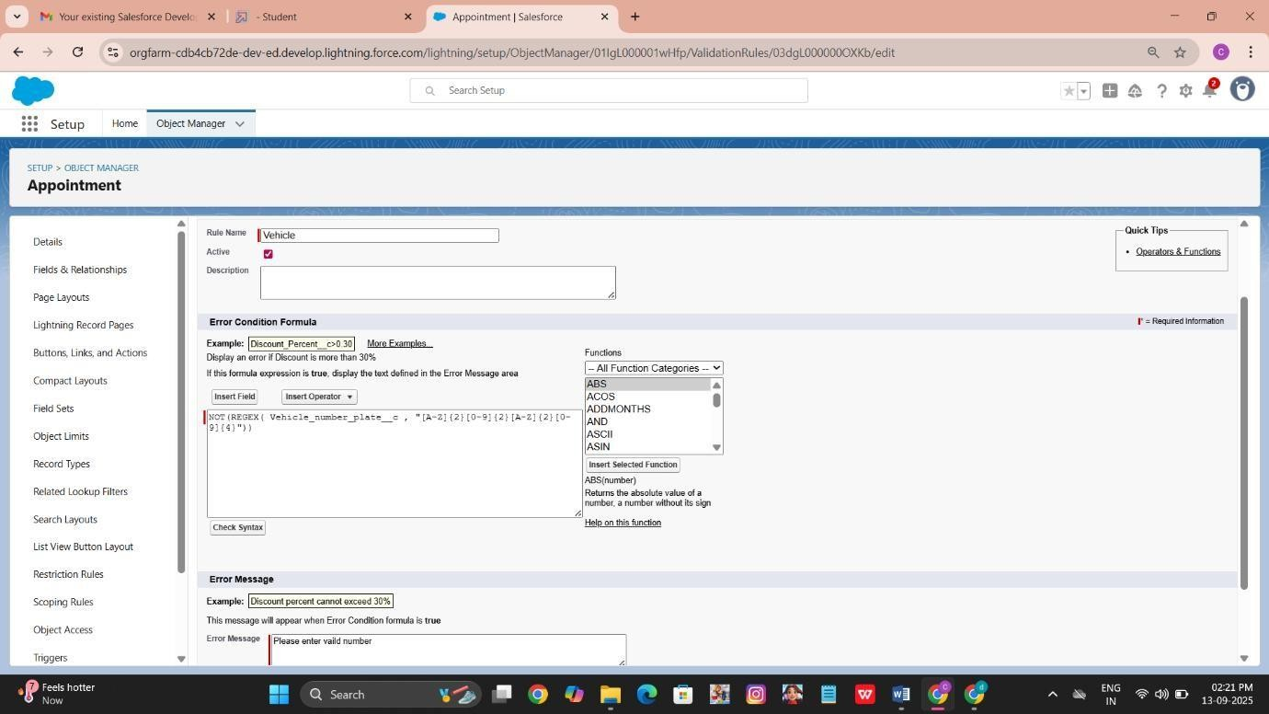create a validation rule to an Appointment Object

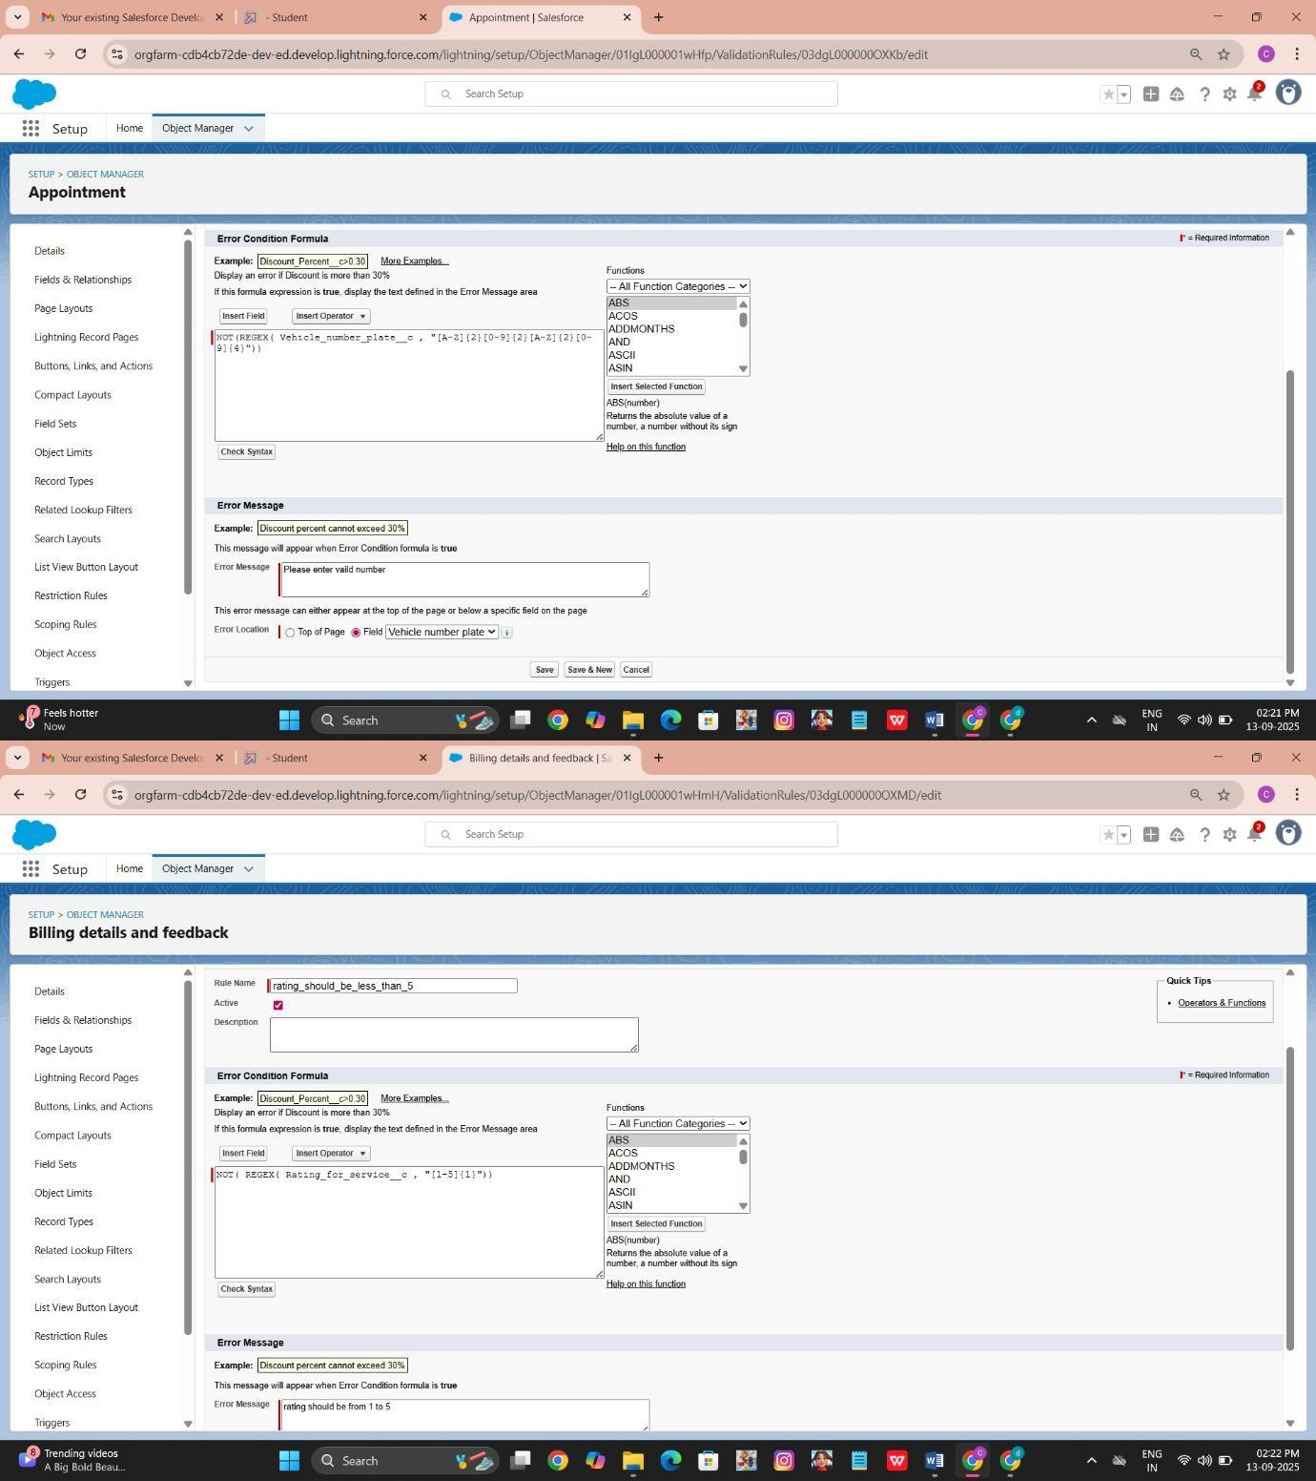

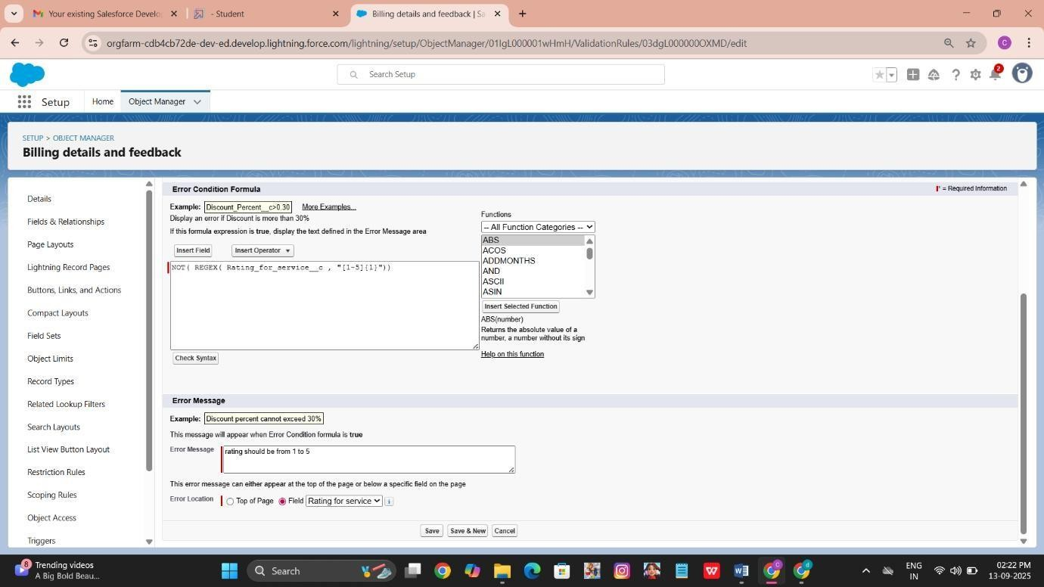

### Duplicate rule

* + - * + To create a matching rule to an Customer details Object

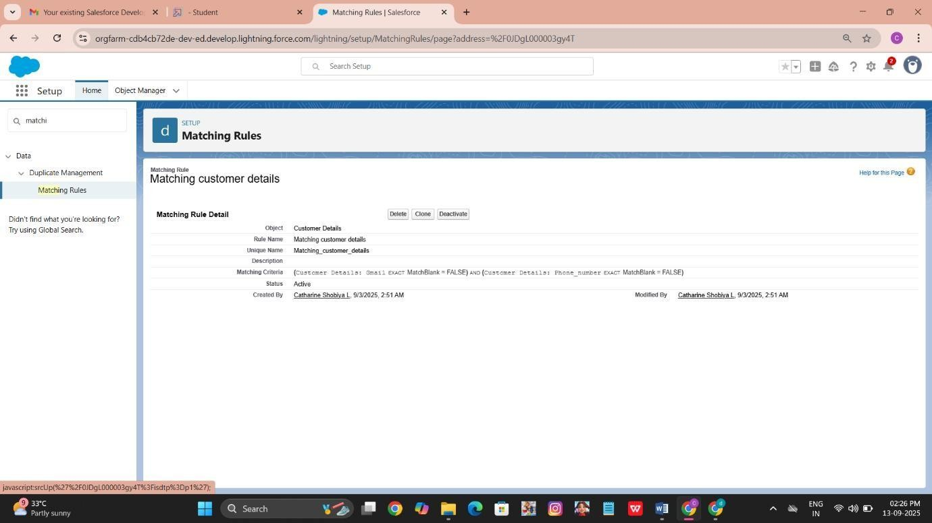

* + - * + create a Duplicate rule to an Customer details Object,

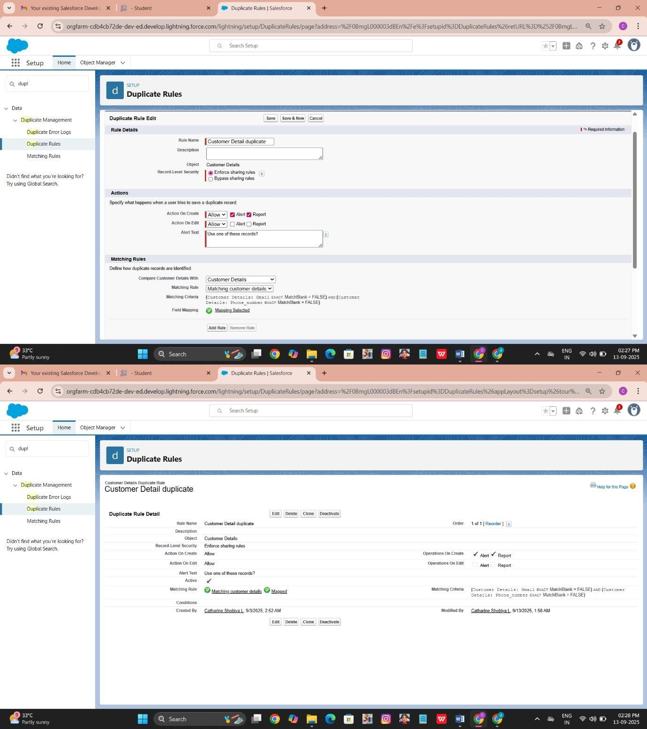

### Profiles

Manager Profile,

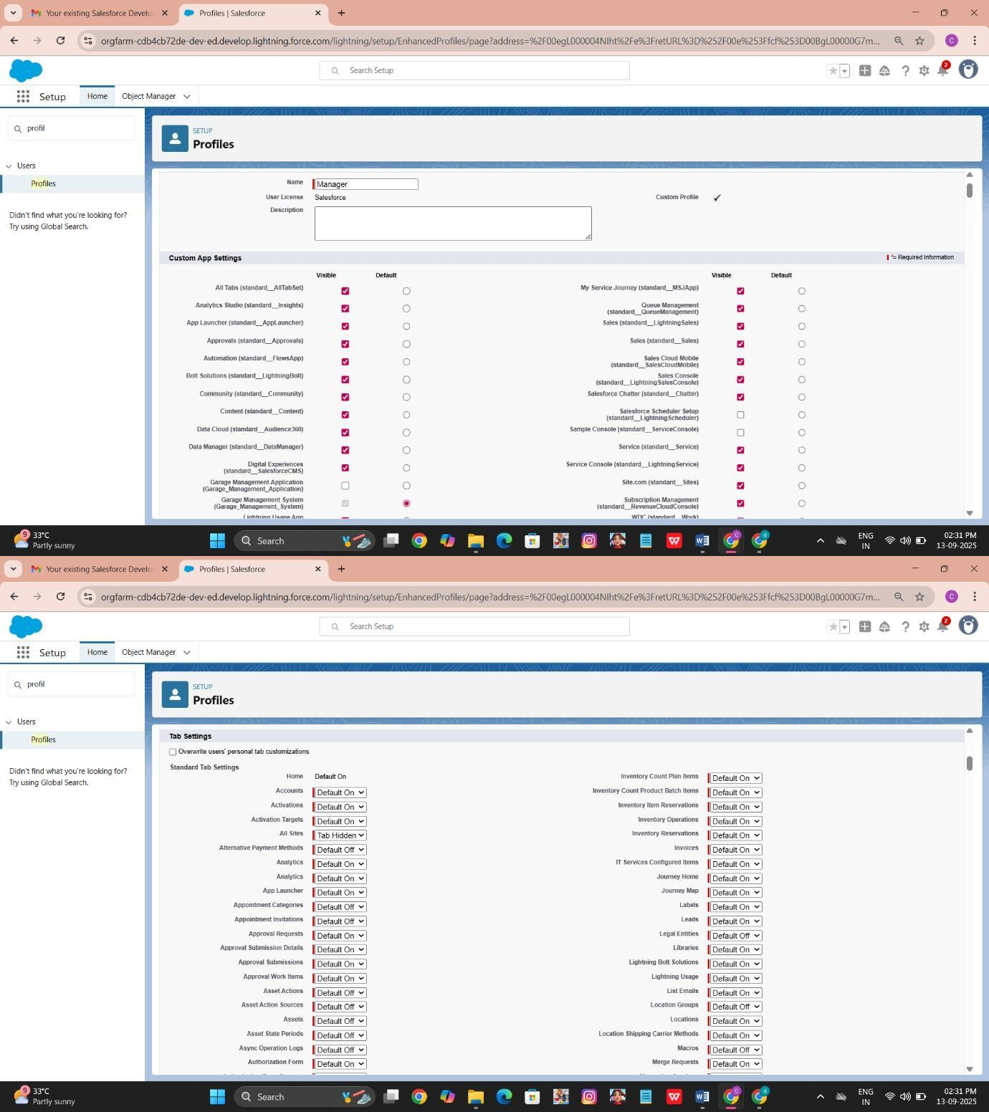

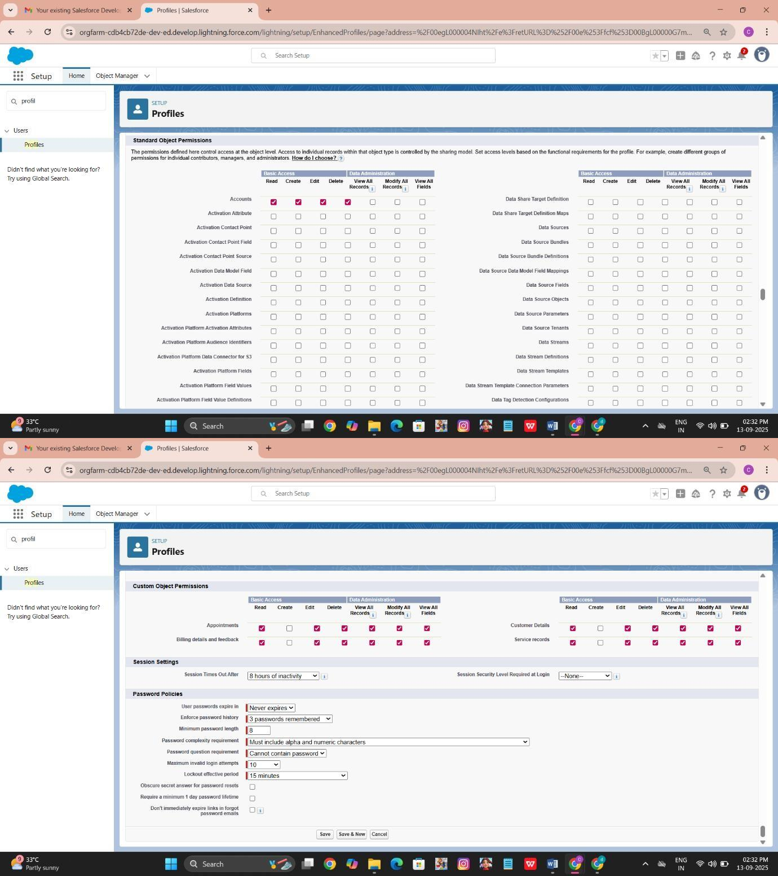

### Role & Role Hierarchy

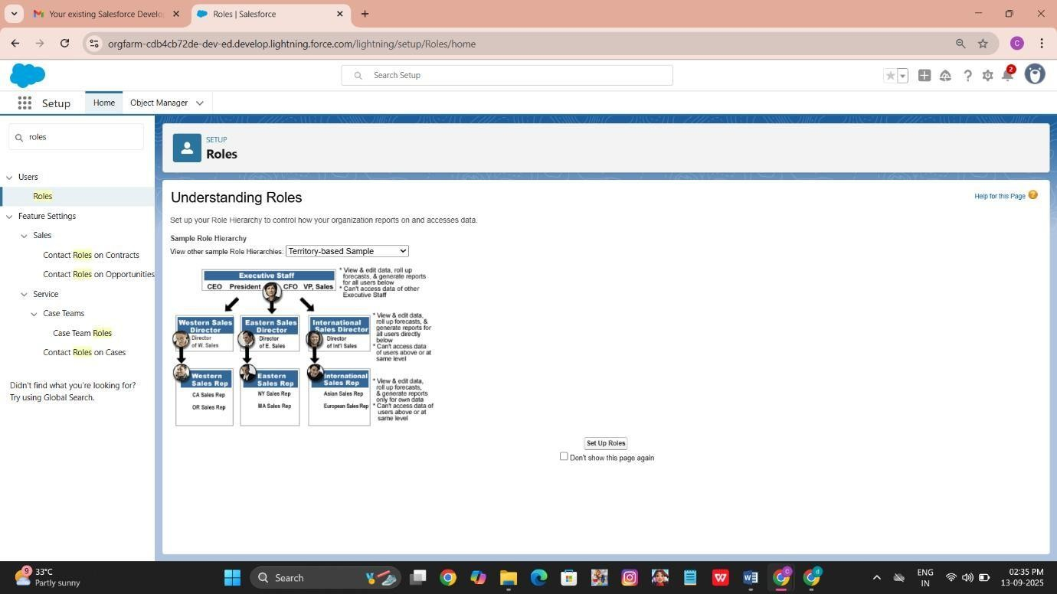

* Creating Manager Role,

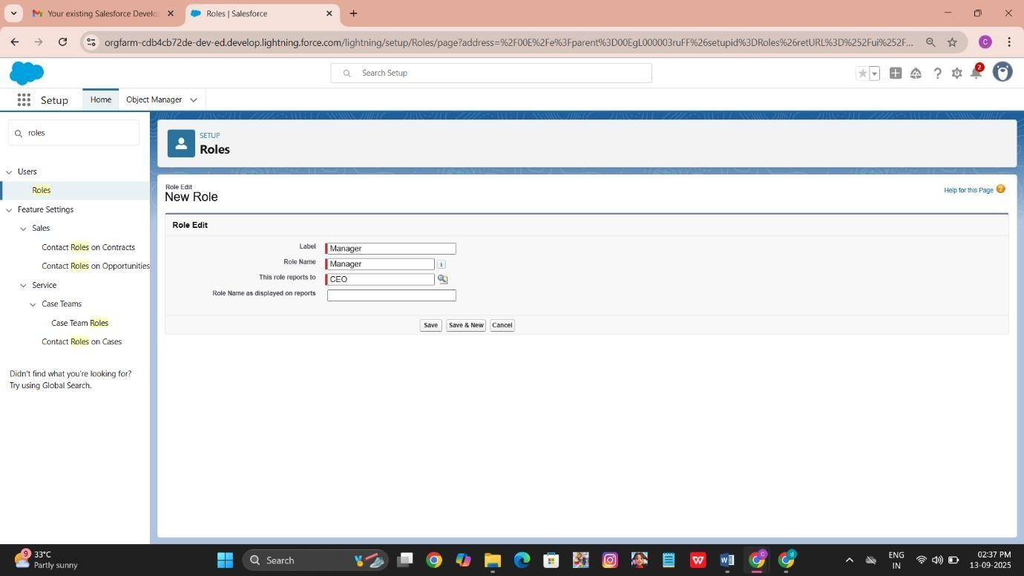

* Creating Sales person Role,

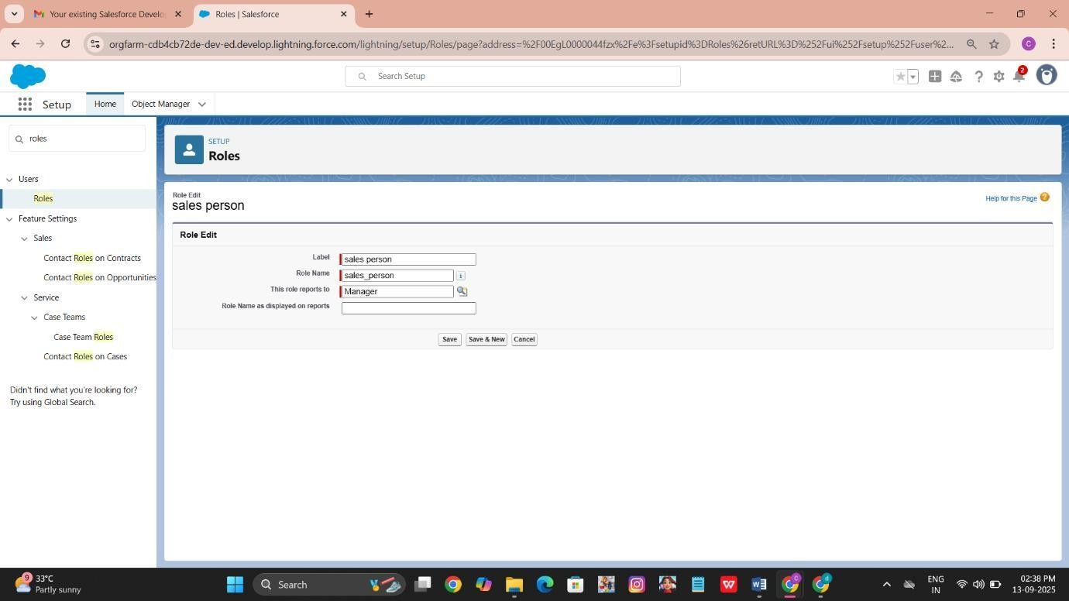

### Users

* 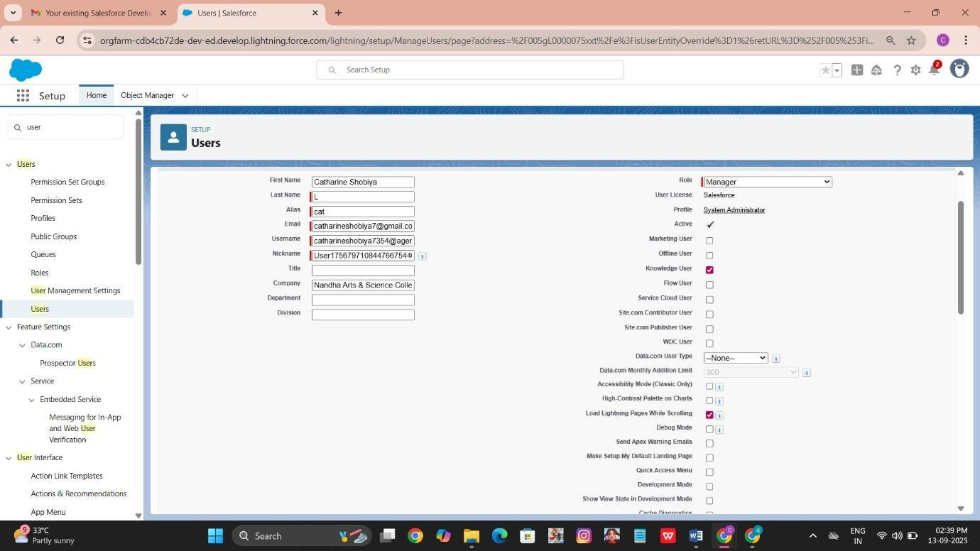Create User assign the role as Manager
* Create User assign the role as sales person

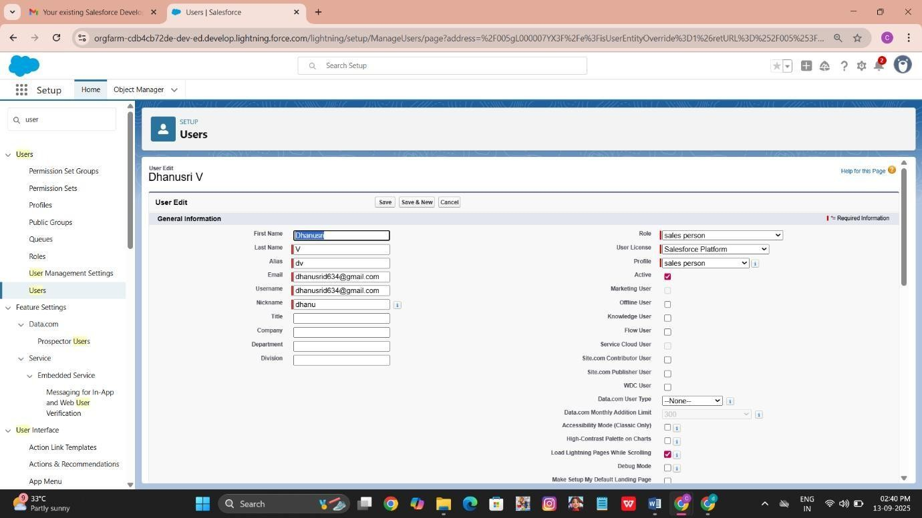

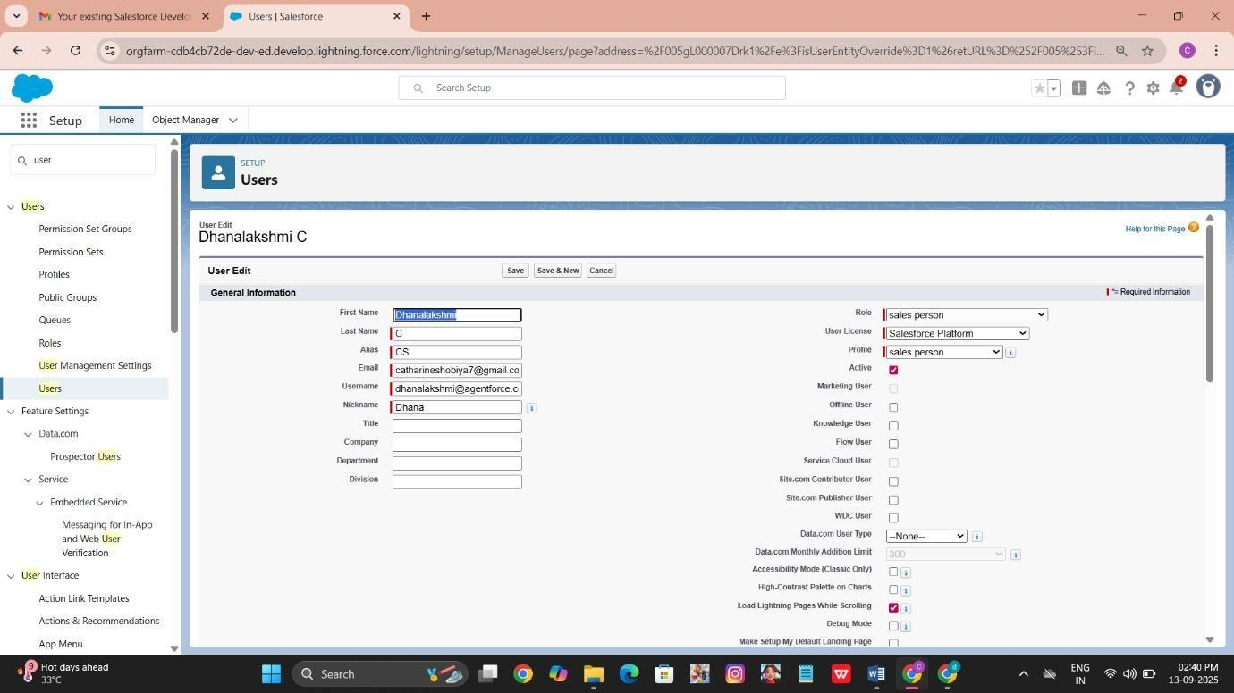

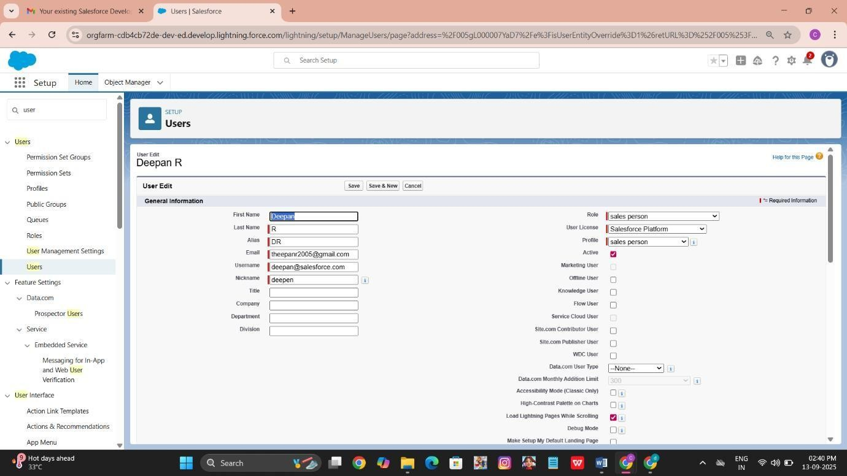

### Public groups

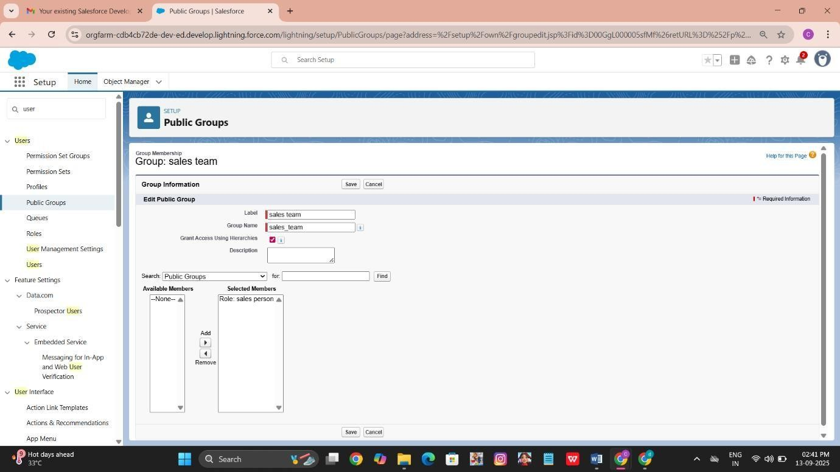Creating New Public Group name with Sales Team,

### Sharing Setting

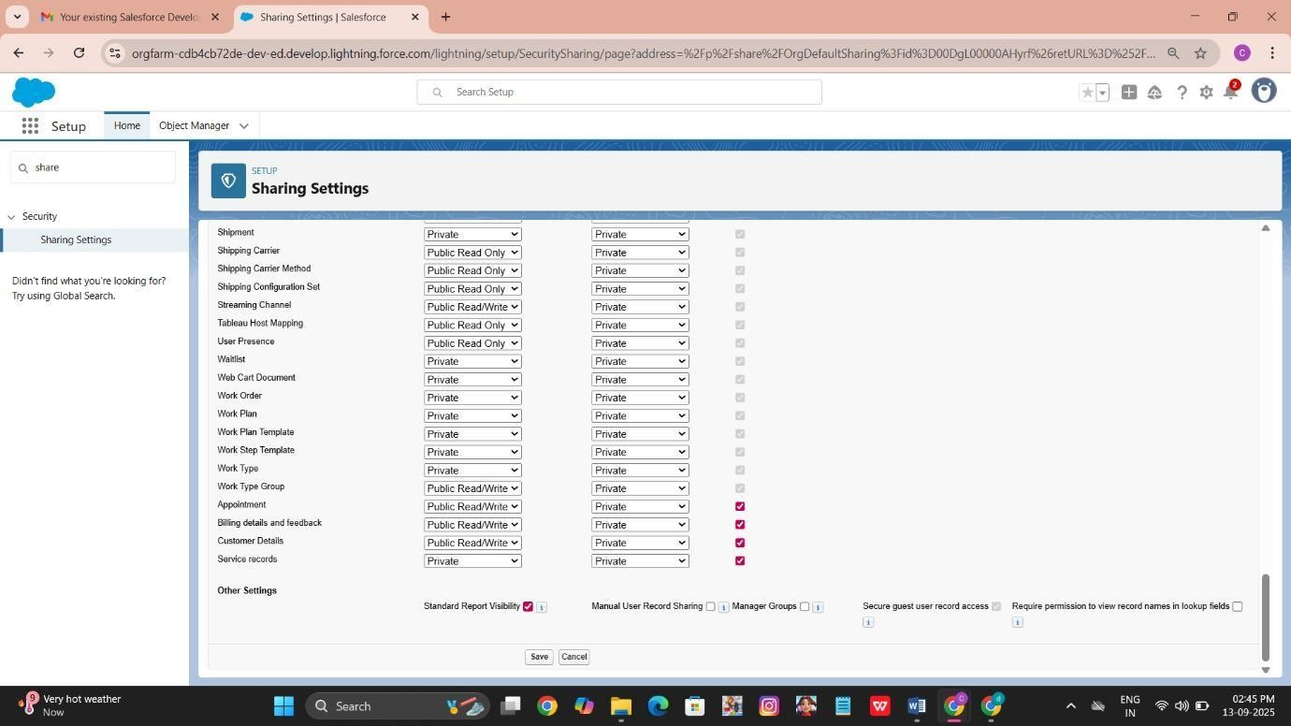Creating Sharing settings,

### Flows

* + Create a flow for a Billing details and

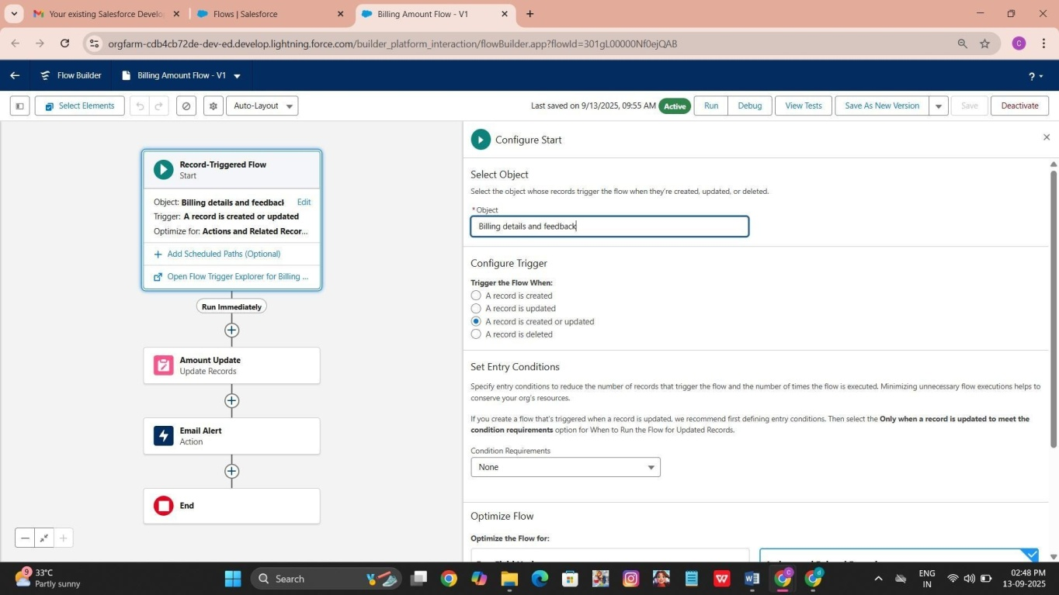

feedback,

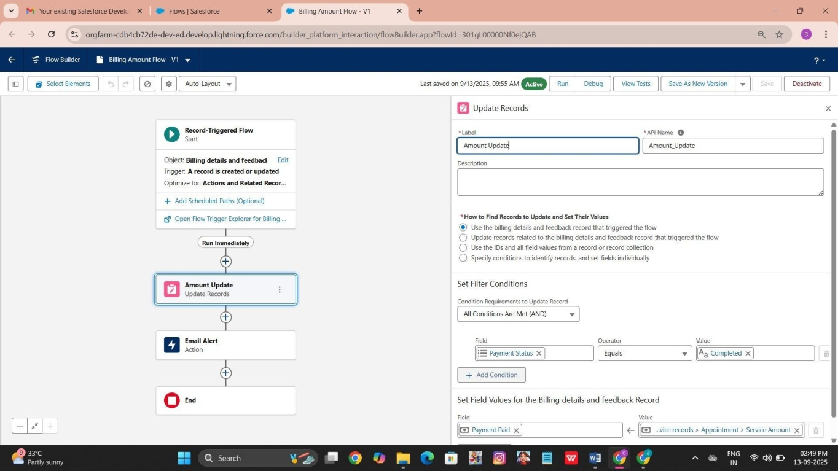

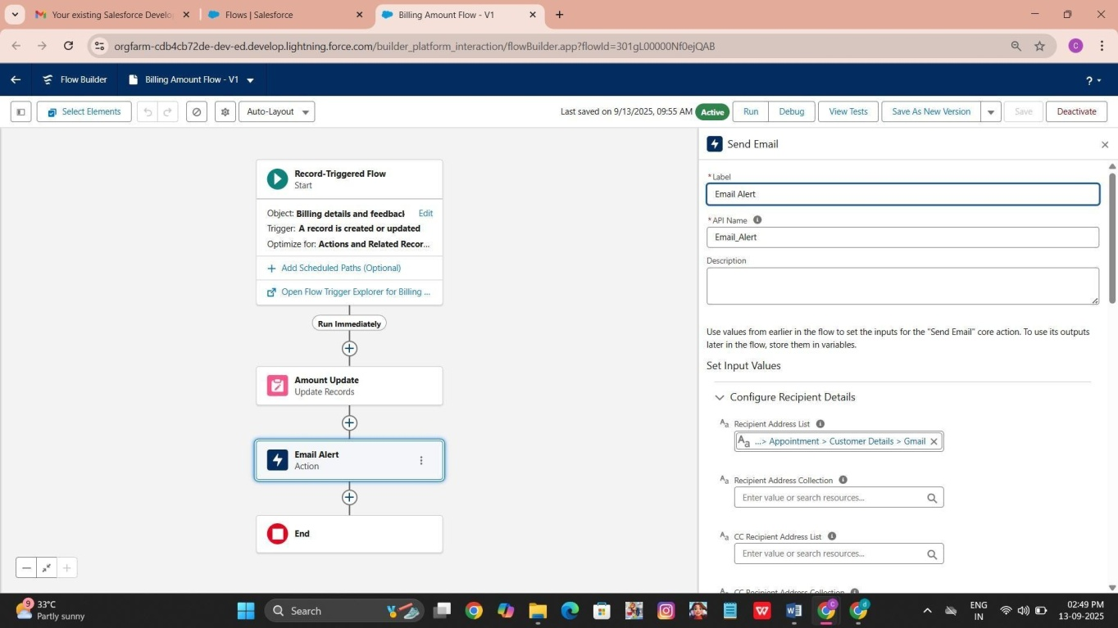

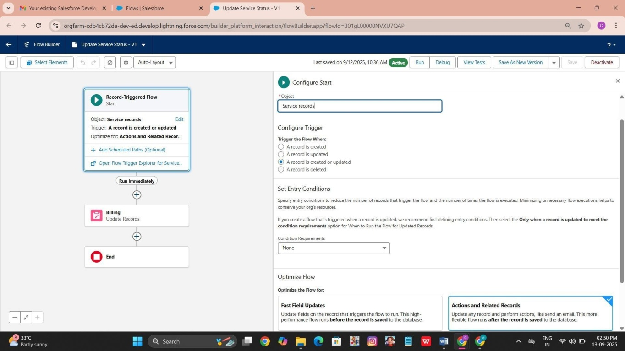

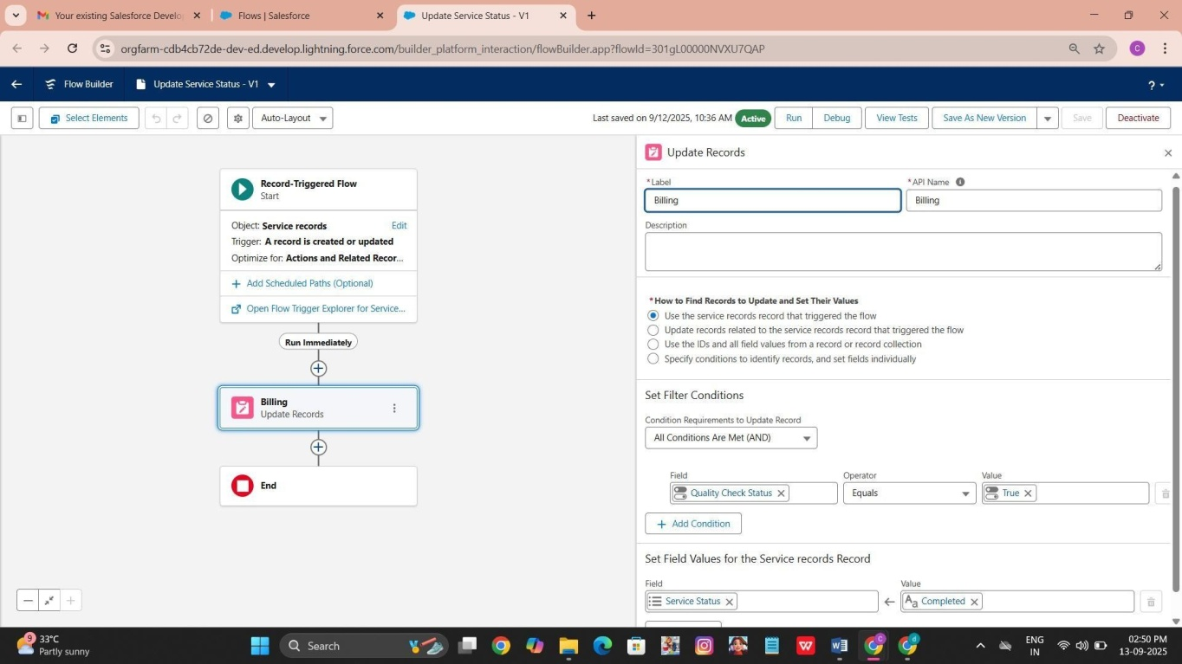

Apex Trigger Create an Apex Handler class

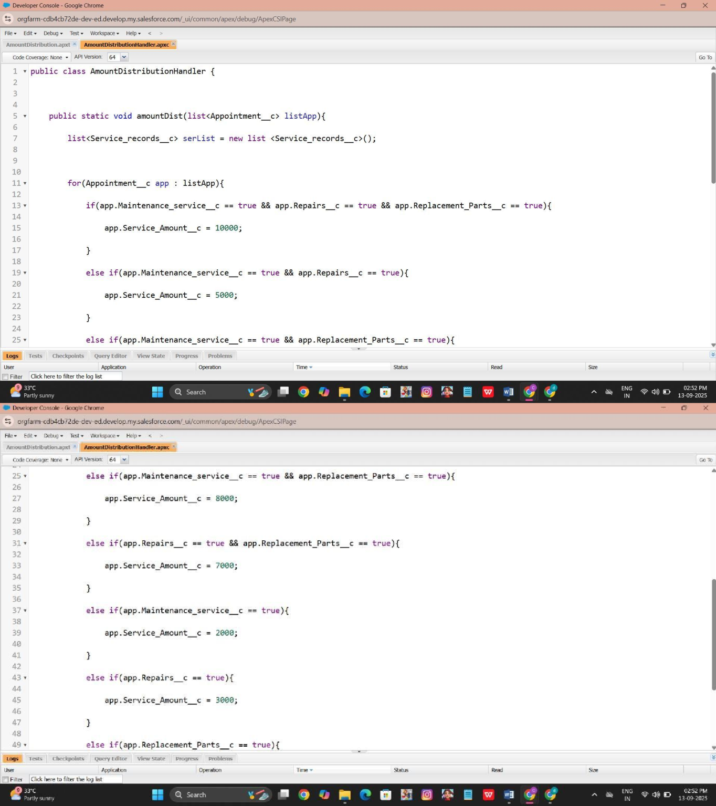

* Create an Apex Trigger

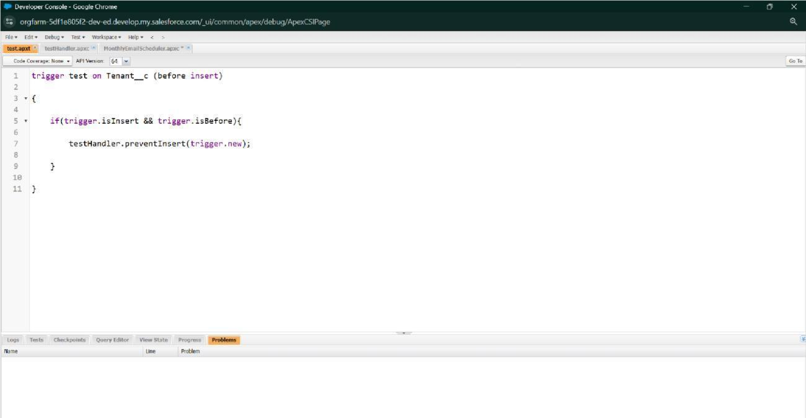

### Reports

* create a report folder

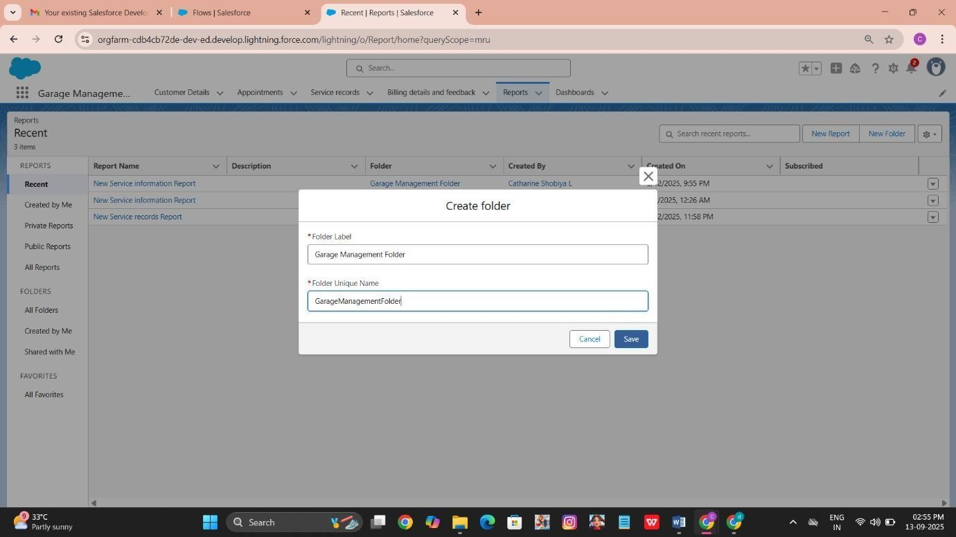

* Sharing a report folder

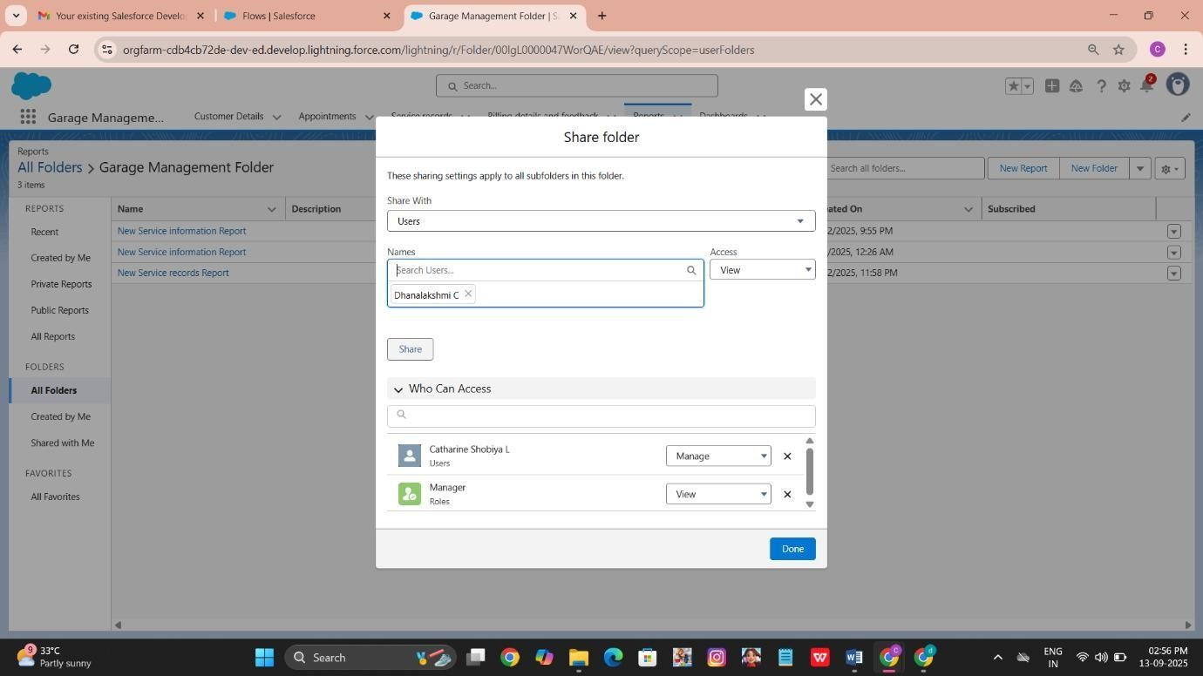

* Create Report Type

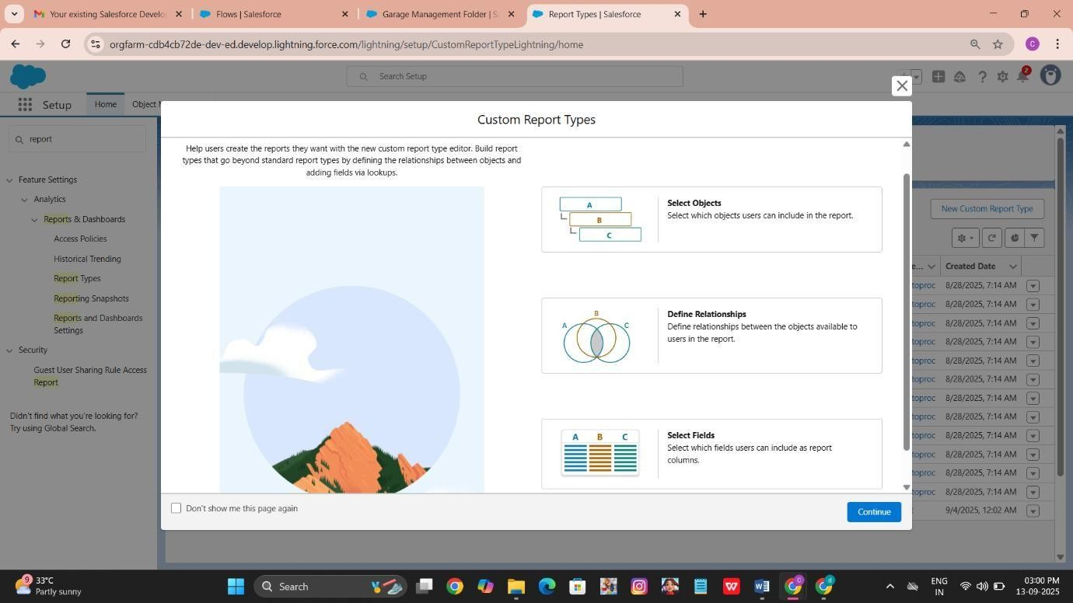

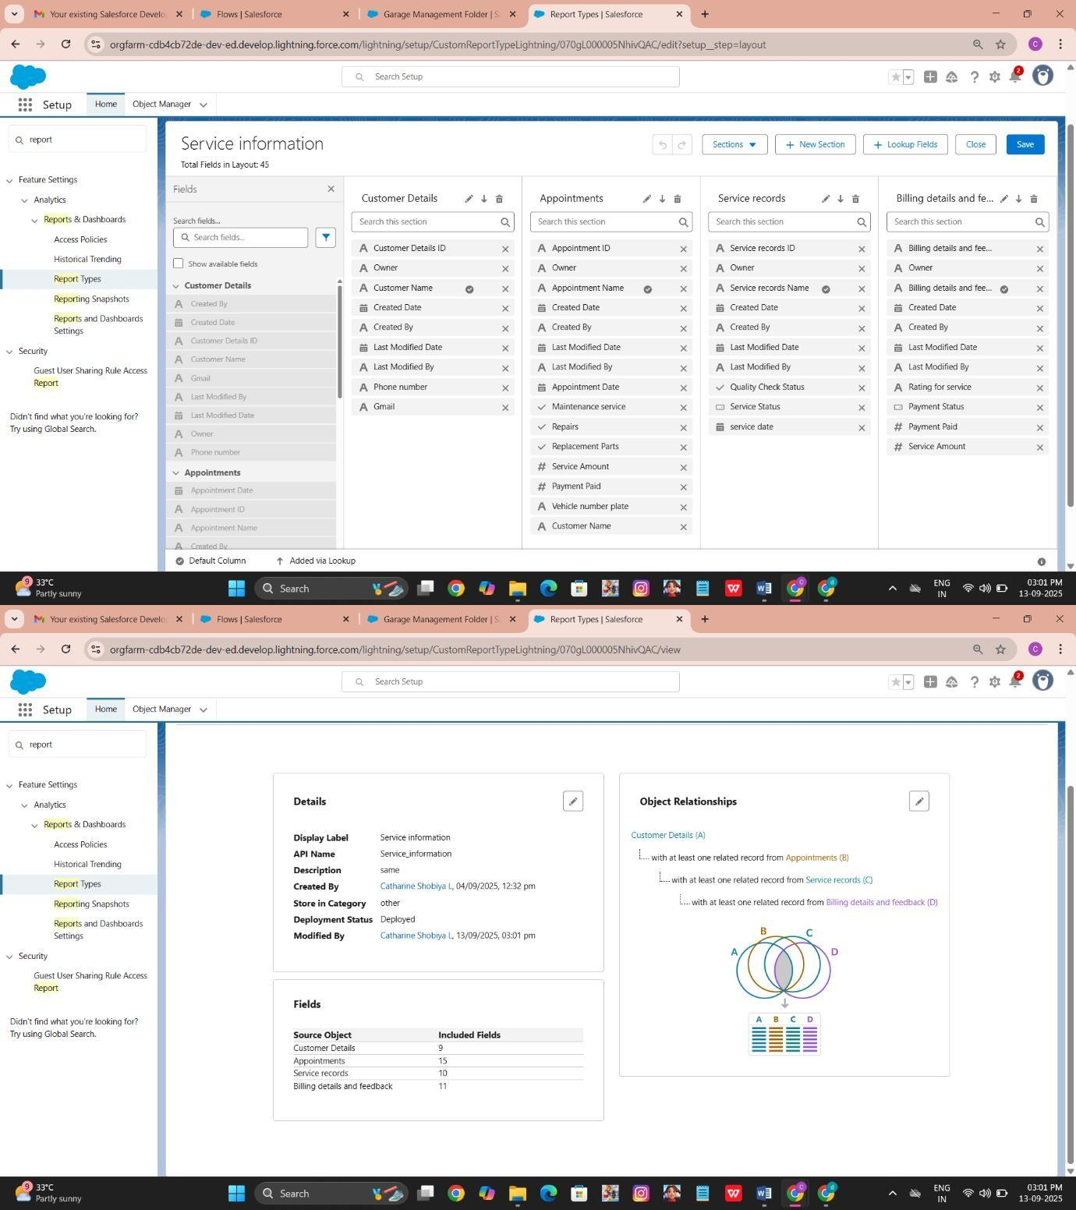

* Create Report

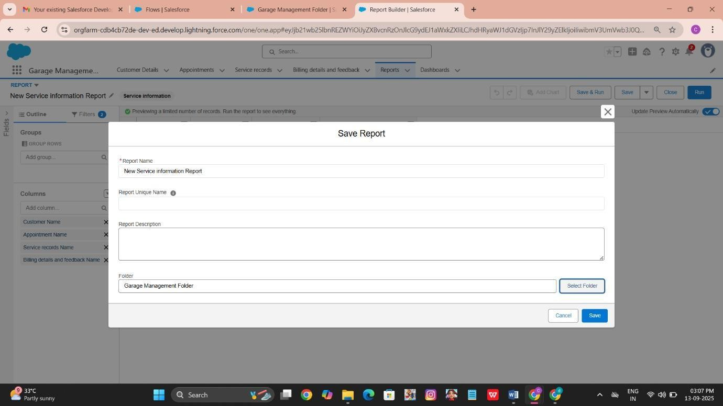

### Dashboards

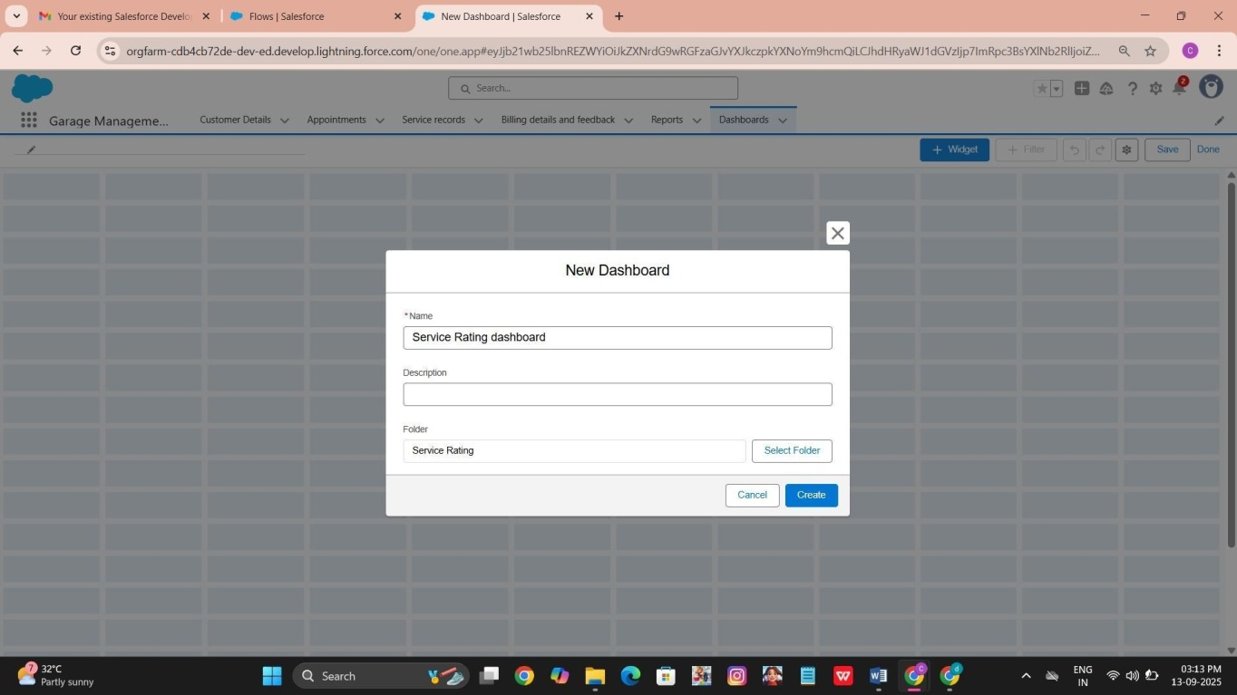Create Dashboard Folder

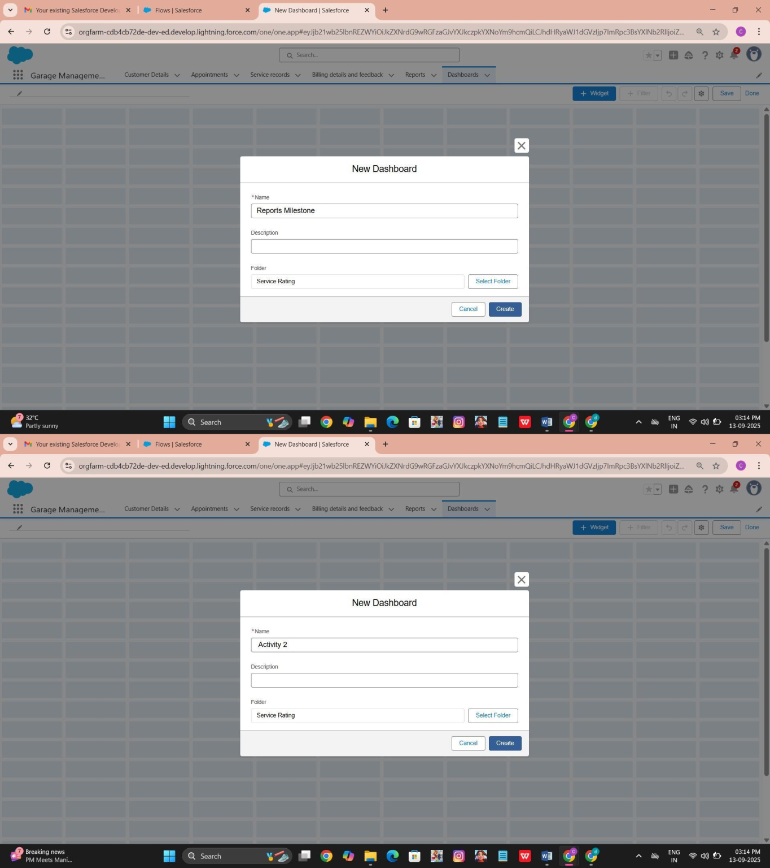

### User Adoption

creating records

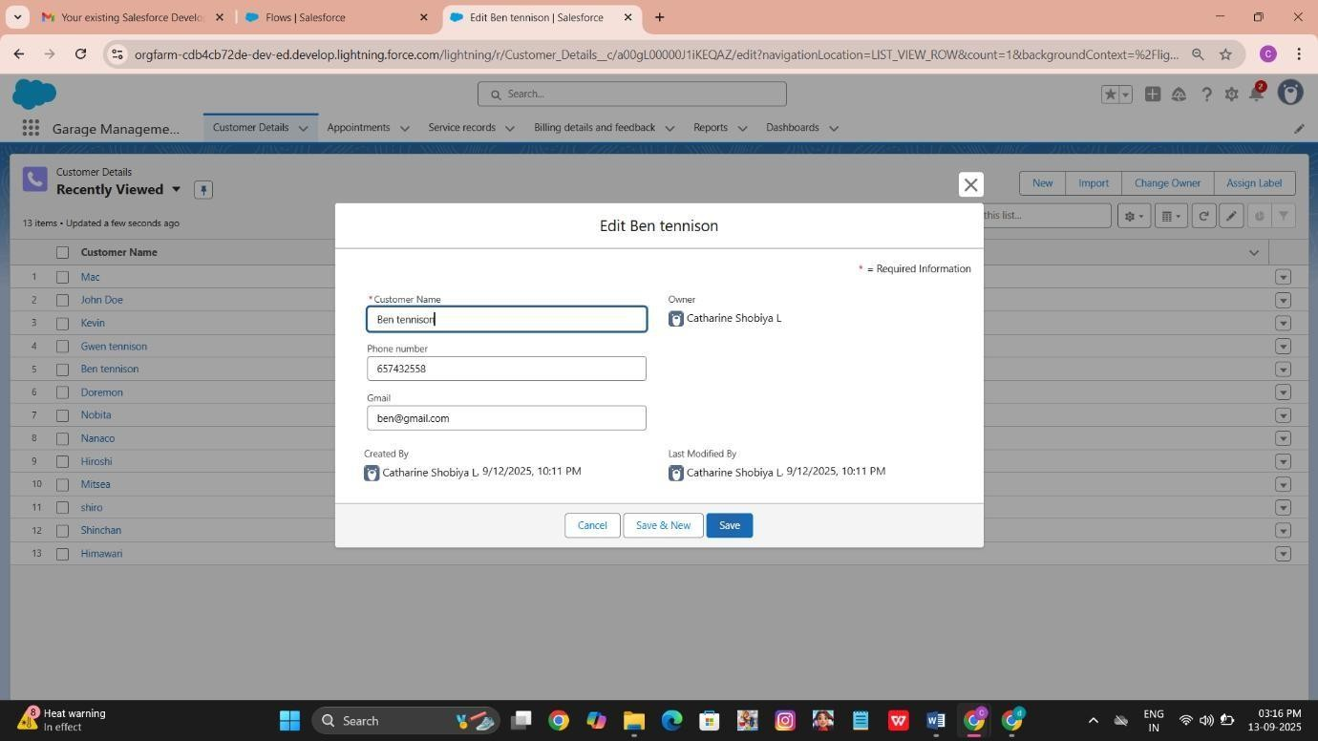

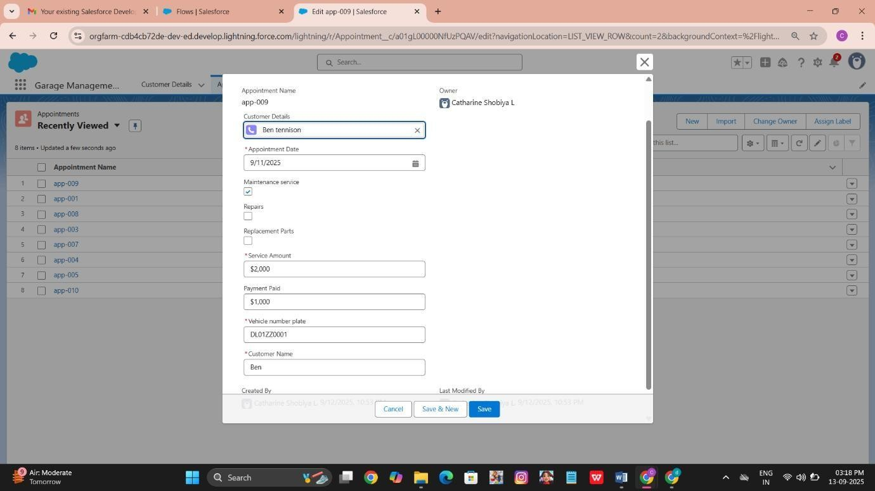

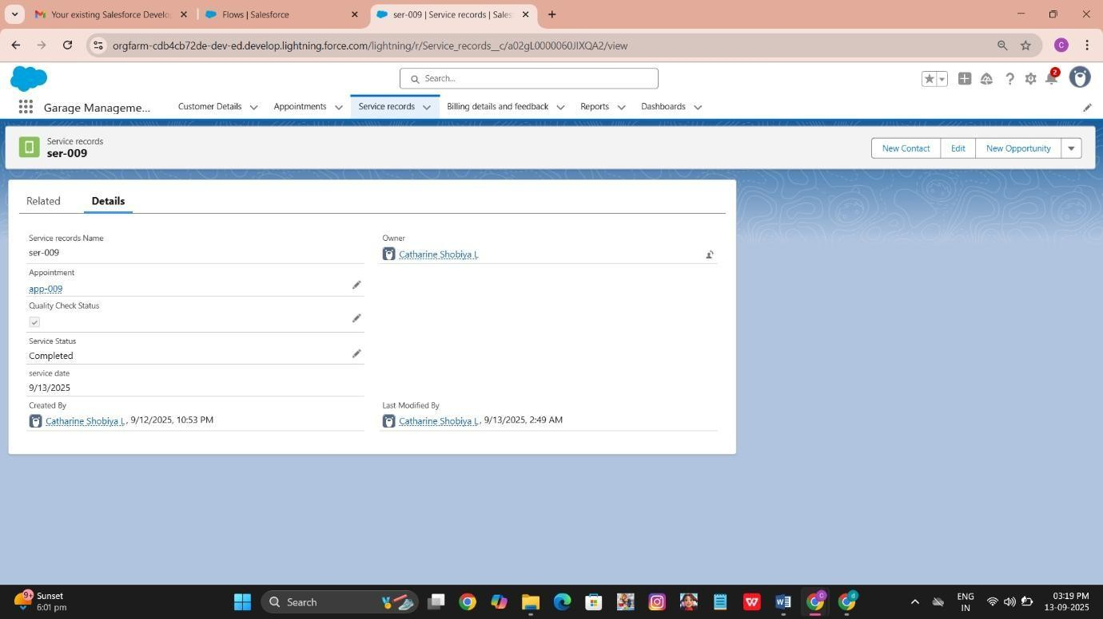

# FUNCTIONAL AND PERFORMANCE TESTING

Performance Testing

* Trigger validation by entering duplicate service amount records

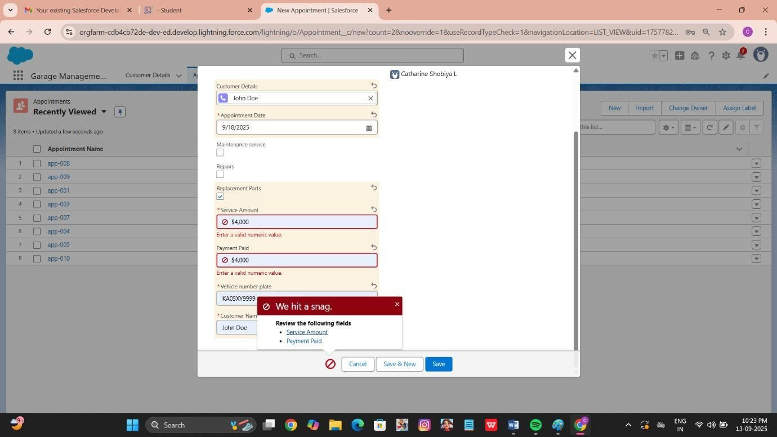

* Validation Rule checking

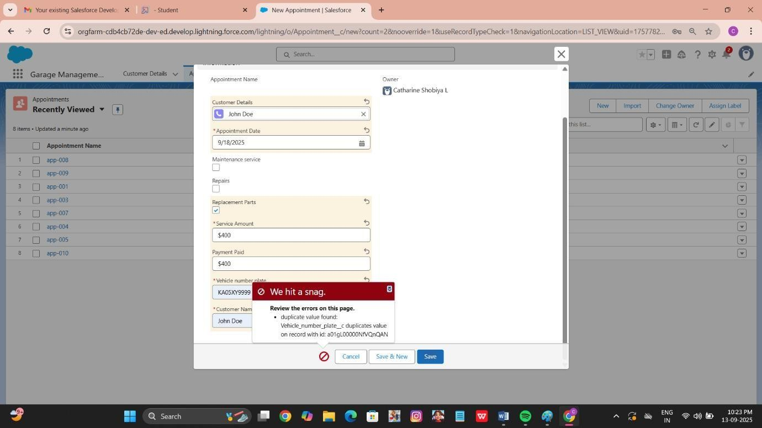

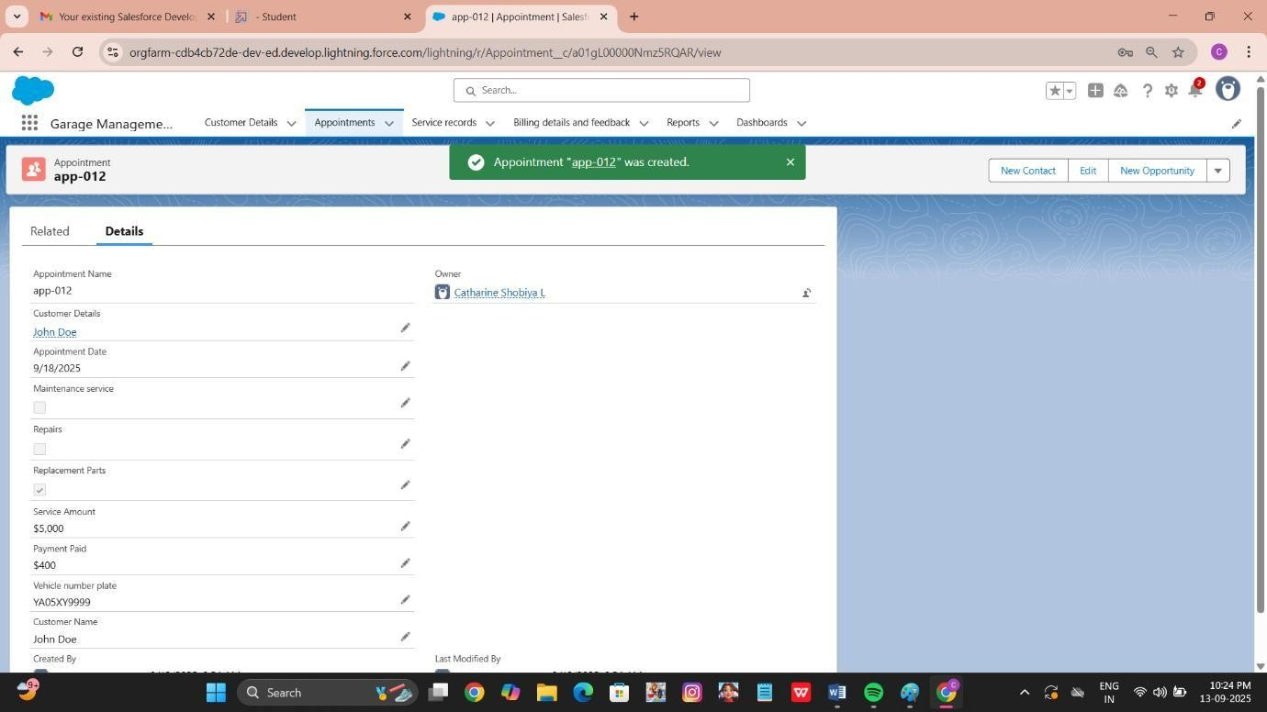

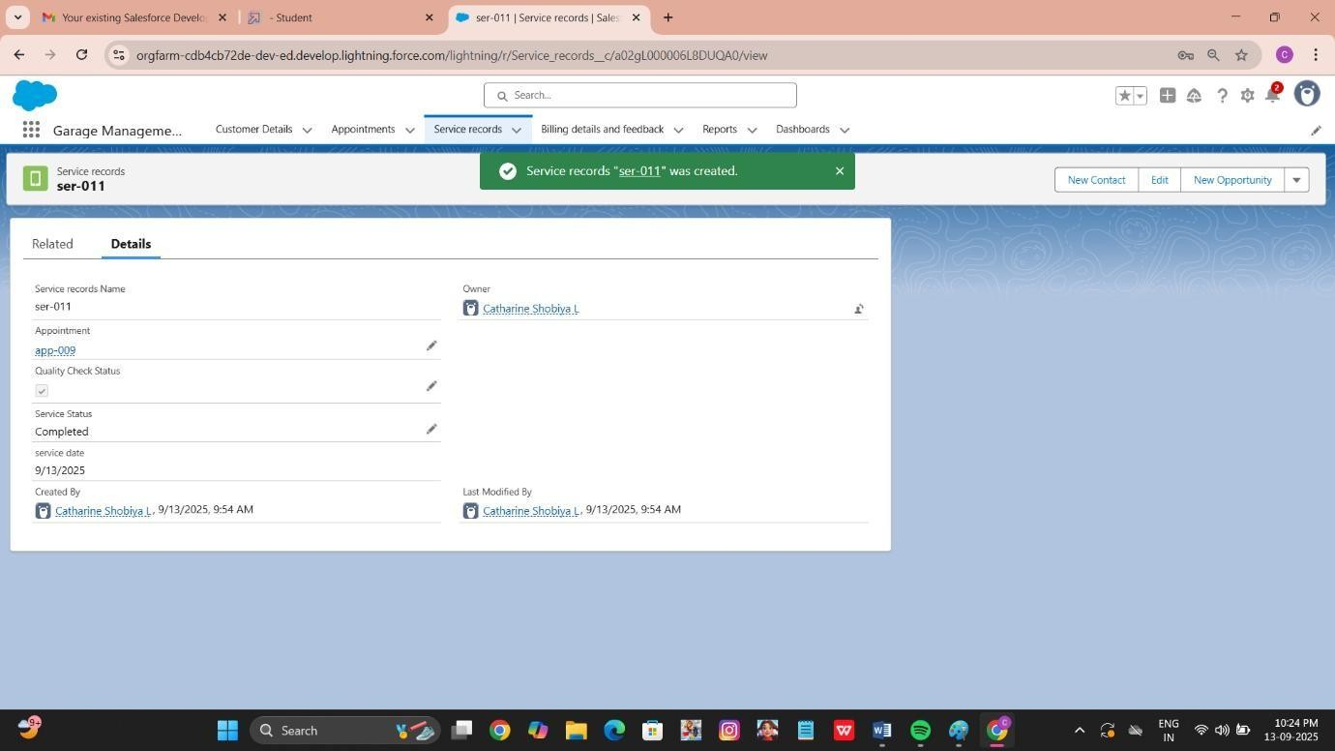

* Test flows on payment update

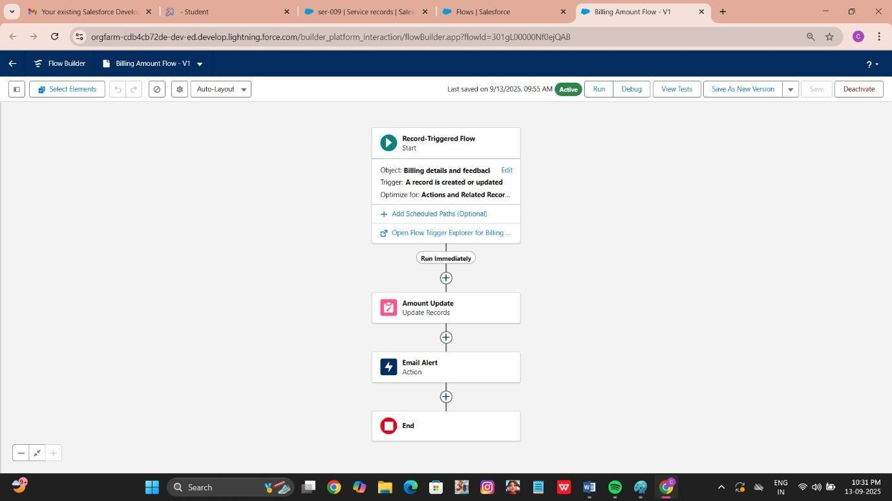

# RESULTS

## Output Screenshots

* Tabs for Customer Details, Appointment, Service records, Billing details and feedback



Appointments of the Customers

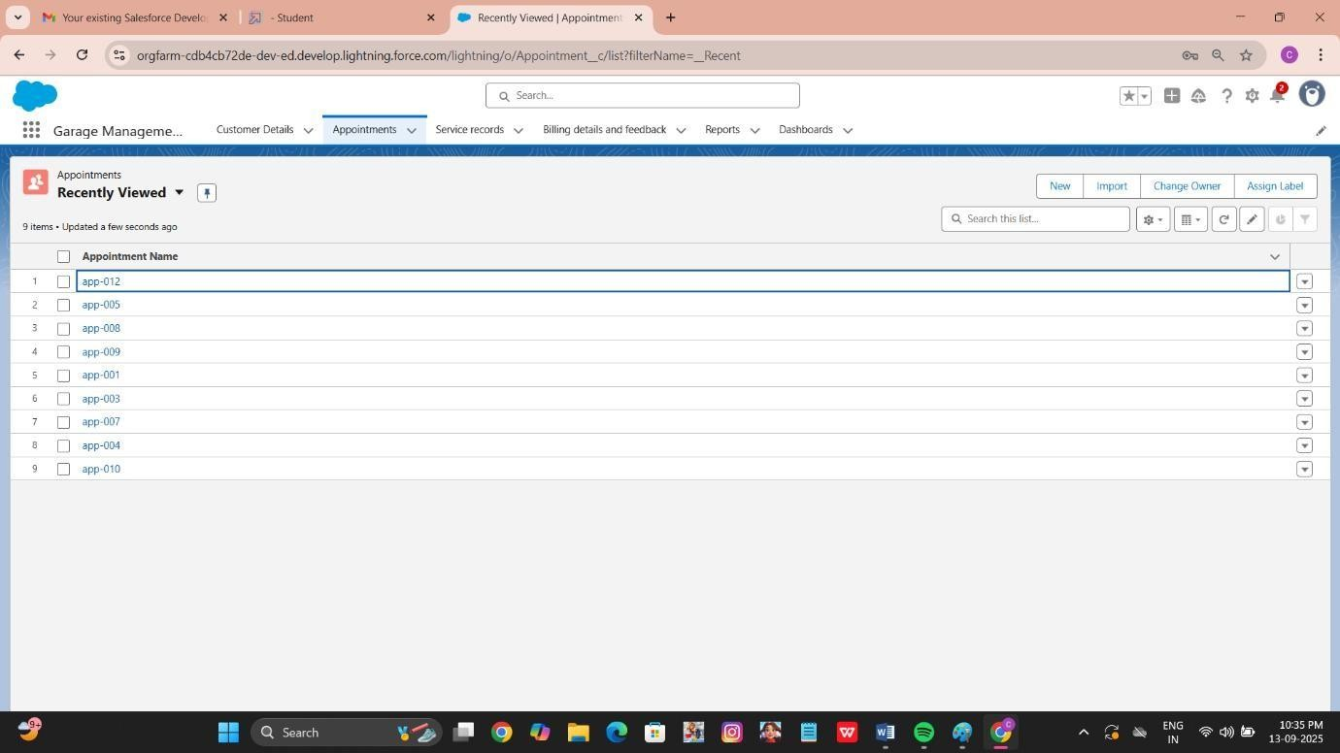

* Flow runs



* Trigger error messages



* Approval process



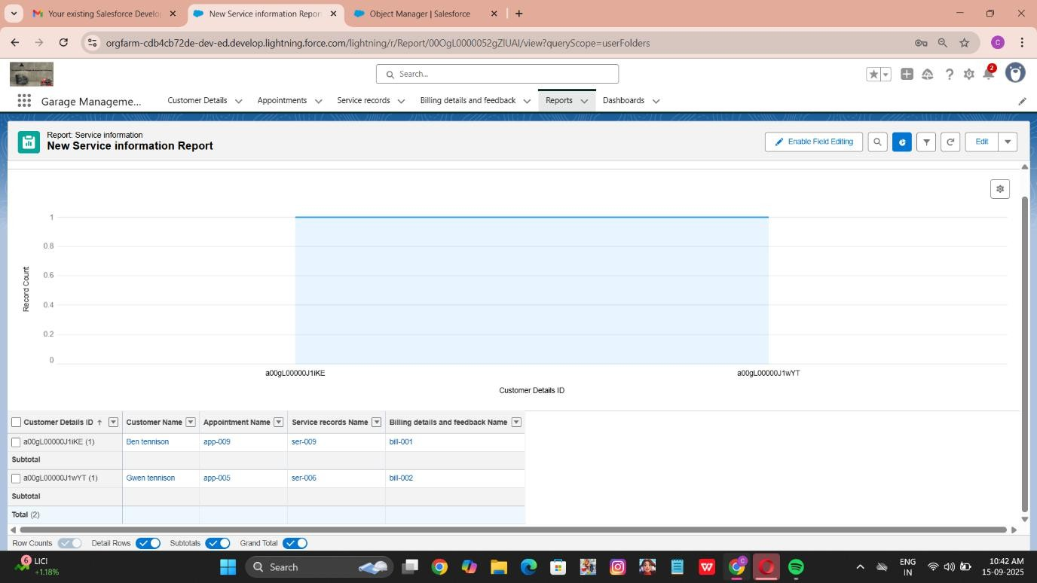

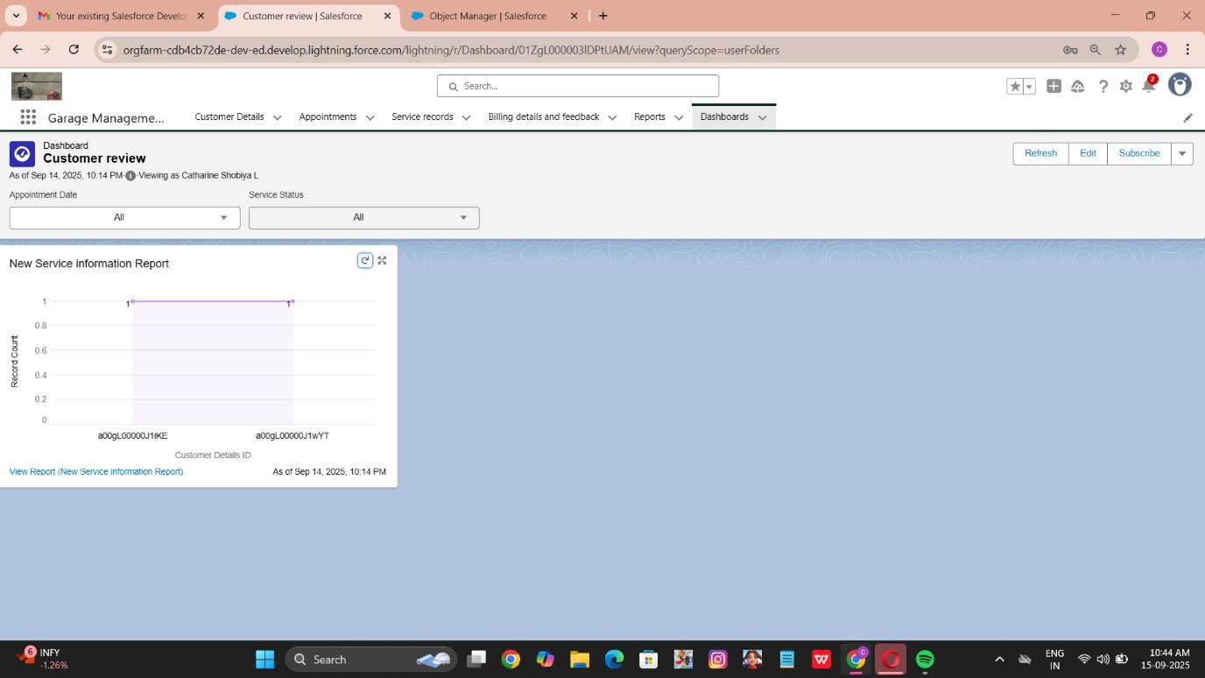

# ADVANTAGES & DISADVANTAGES

### ADVANTAGES:

* Automation of tasks → Reduces manual paperwork and human errors.
* Centralized data → Easy access to customer, vehicle, and job records in one place.
* Time efficiency → Faster job assignment, billing, and report generation.
* Inventory control → Real-time tracking of spare parts stock and usage.
* Improved customer service → Quicker updates and accurate invoices increase customer satisfaction.
* Decision-making support → Generates reports that help management plan resources and future growth.

### DISADVANTAGES:

* Initial setup cost → Requires investment in software, hardware, and training.
* Technical dependency → Staff must learn to use the system effectively.
* Maintenance required → Regular updates and backups are necessary to keep the system reliable.
* Limited offline use → System performance may depend on computer or internet availability.

# CONCLUSION

The Garage Management System successfully fulfills its objectives of automating and simplifying the day-to-day operations of automobile service centers. By digitizing processes such as customer registration, vehicle management, job assignment, inventory tracking, and billing, the system reduces manual workload, minimizes errors, and enhances efficiency.It not only improves internal workflow for garage staff but also ensures better service quality for customers through faster processing and accurate record-keeping. The modular design of the system allows for scalability and future enhancements, making it adaptable for garages of various sizes.Overall, the GMS provides a reliable, efficient, and user-friendly solution that bridges the gap between traditional manual processes and modern digital management practices.

## APPENDIX

* + **Source Code:** Provided in Apex Classes and Triggers AmountDistribution.apxt:

trigger AmountDistribution on Appointment c (before insert, before update) {

if(trigger.isbefore && trigger.isinsert || trigger.isupdate){

AmountDistributionHandler.amountDist(trigger.new);

}

}

AmountDistributionHandler.apxc: public class

AmountDistributionHandler { public static void

amountDist(list<Appointment c> listApp){

list<Service_records c> serList = new list <Service_records c>();

for(Appointment c app : listApp){

if(app.Maintenance_service c == true && app.Repairs c == true && app.Replacement_Parts c == true){

app.Service_Amount c = 10000;

}

else if(app.Maintenance_service c == true && app.Repairs c ==

true){ app.Service_Amount c = 5000;

}

else if(app.Maintenance_service c == true && app.Replacement_Parts c == true){

app.Service_Amount c = 8000;

}

else if(app.Repairs c == true && app.Replacement_Parts c == true){

app.Service_Amount c = 7000;

}

else if(app.Maintenance_service c == true){

app.Service_Amount c = 2000;

}

else if(app.Repairs c == true){

app.Service_Amount c = 3000;

}

else if(app.Replacement_Parts c == true){

app.Service_Amount c = 5000;

}

}

}

}